**MongoDB Lab Assignments -Day 1**

Connect to a running mongo instance, use a database named mongo_practice. Document all your queries in a javascript file to use as a reference.

**Insert Documents**

Insert the following documents into a movies collection.

title : Fight Club writer : Chuck Palahniuko year : 1999 actors : [ Brad Pitt Edward Norton ]

title : Pulp Fiction writer : Quentin Tarantino year : 1994 actors : [ John Travolta Uma Thurman ]

title : Inglorious Basterds writer : Quentin Tarantino year : 2009 actors : [ Brad Pitt Diane Kruger Eli Roth ]

title : The Hobbit: An Unexpected Journey writer : J.R.R. Tolkein year : 2012 franchise : The Hobbit

title : The Hobbit: The Desolation of Smaug writer : J.R.R. Tolkein year : 2013 franchise : The Hobbit

title : The Hobbit: The Battle of the Five Armies writer : J.R.R. Tolkein year : 2012 franchise : The Hobbit synopsis : Bilbo and Company are forced to engage in a war against an array of combatants and keep the Lonely Mountain from falling into the hands of a rising darkness.

title : Pee Wee Herman's Big Adventure

title : Avatar

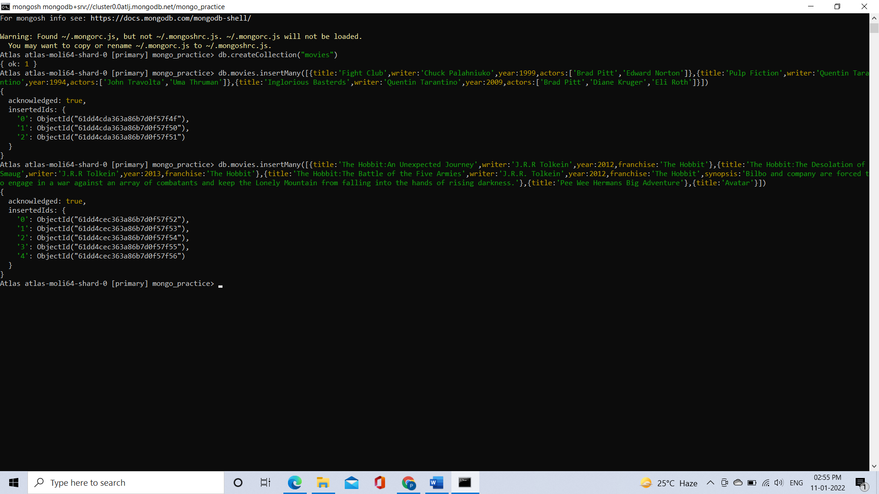

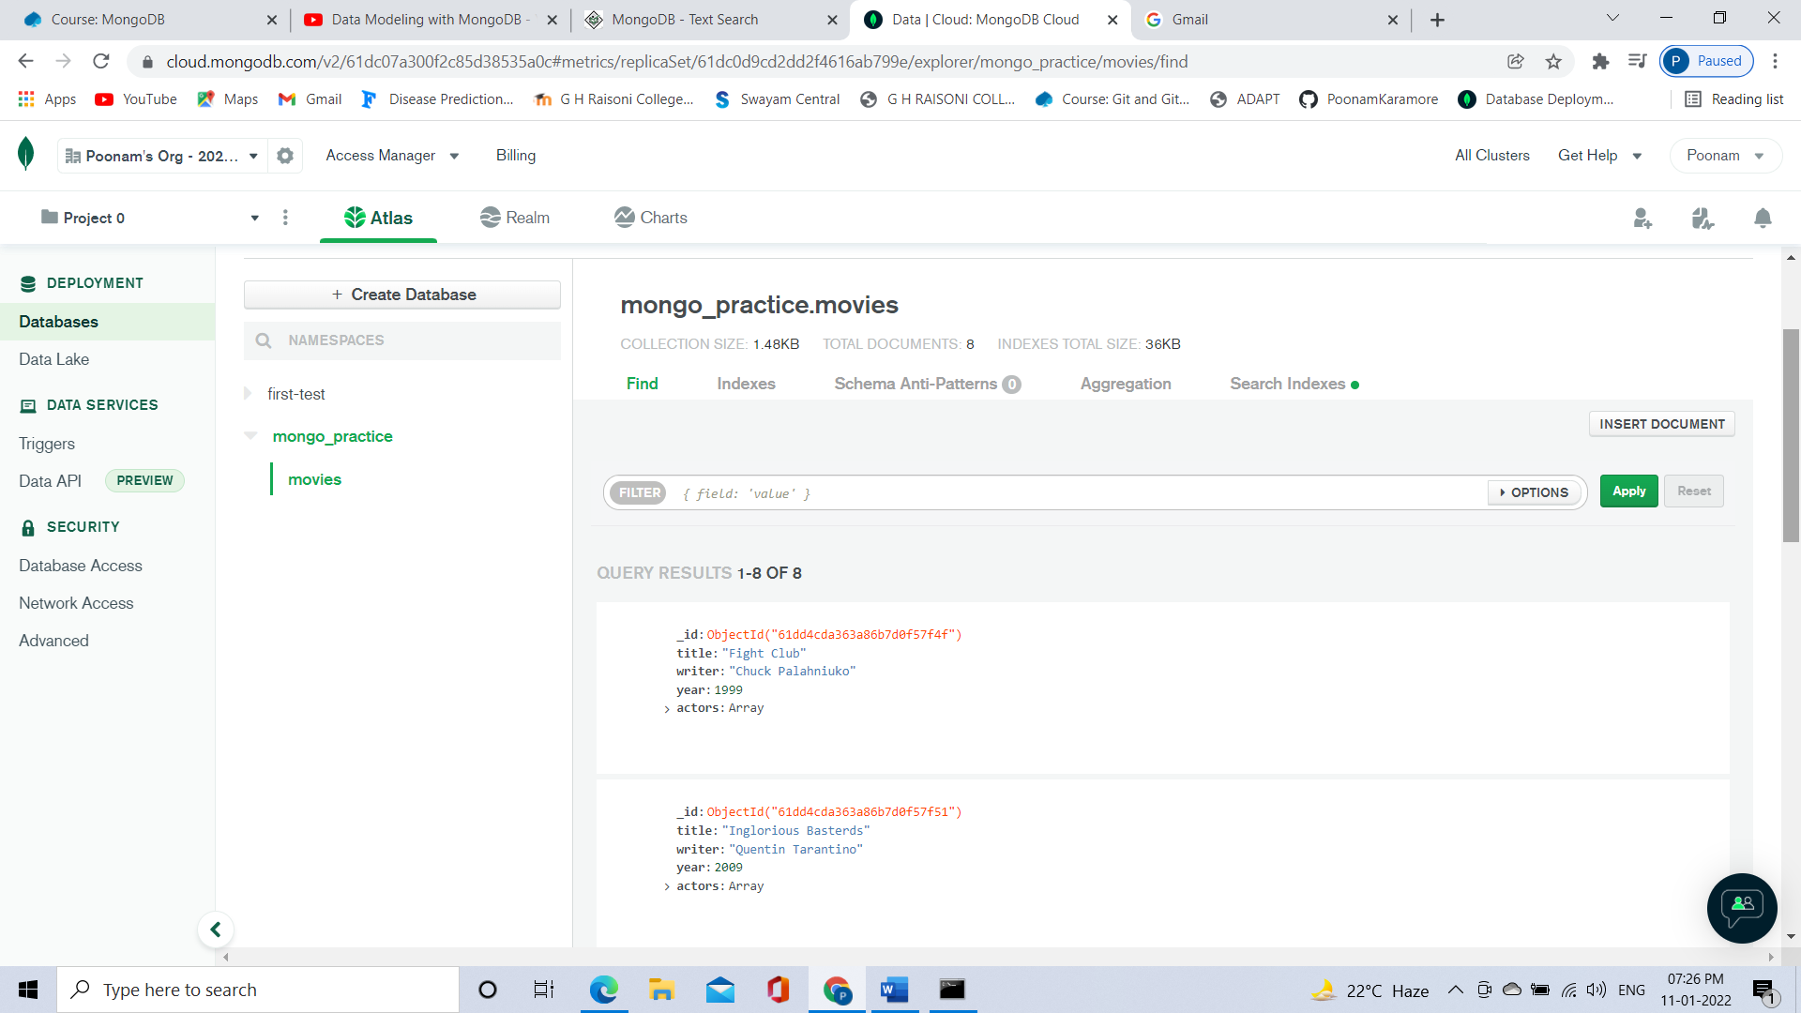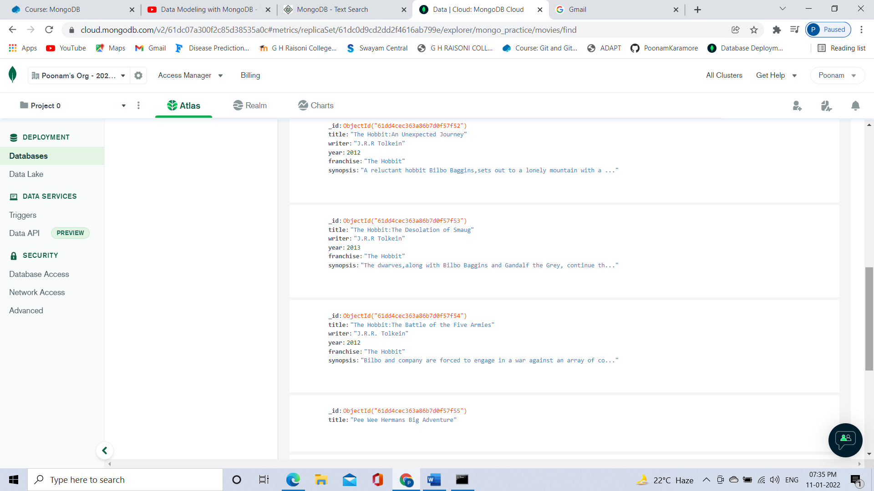

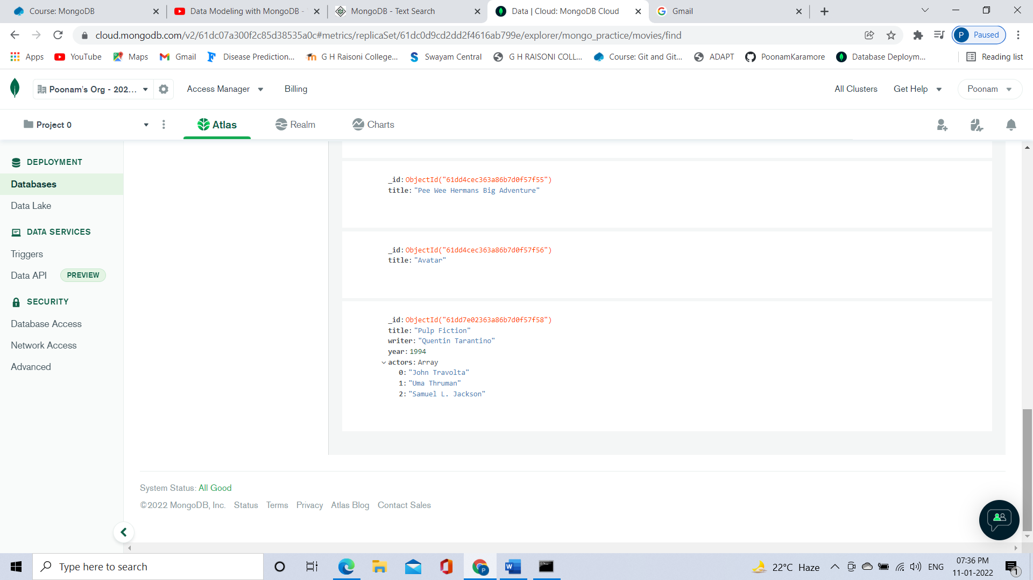

**Query / Find Documents**

query the movies collection to

**1. get all documents**

Command: db.movies.find()

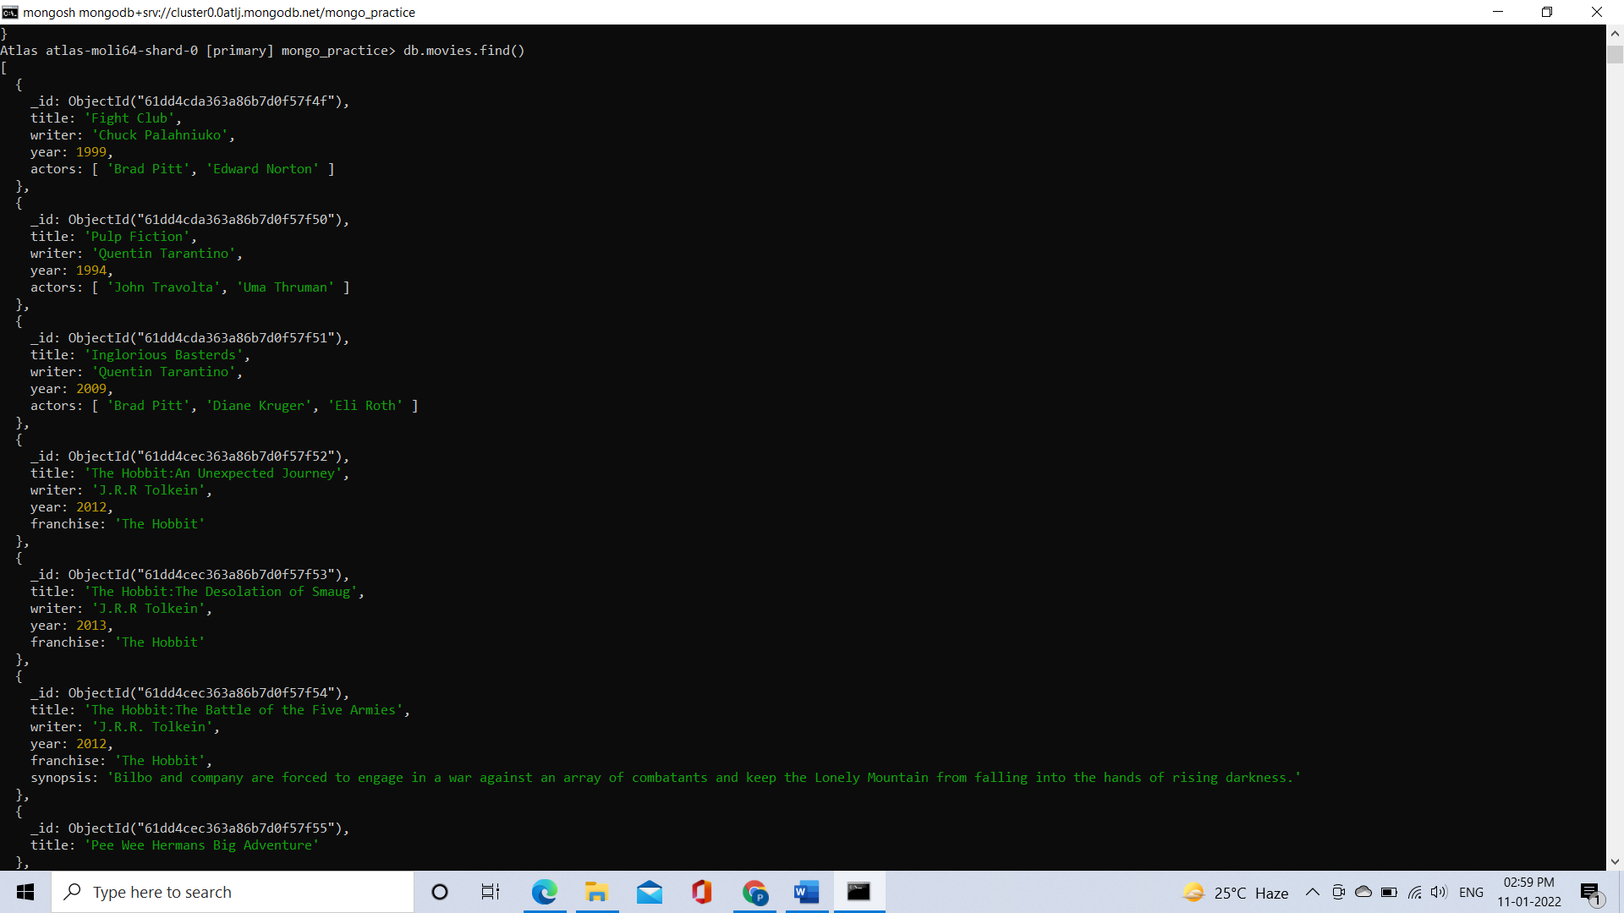

**2. get all documents with writer set to "Quentin Tarantino"**

Command: db.movies.find({writer:” Quentin Tarantino”})

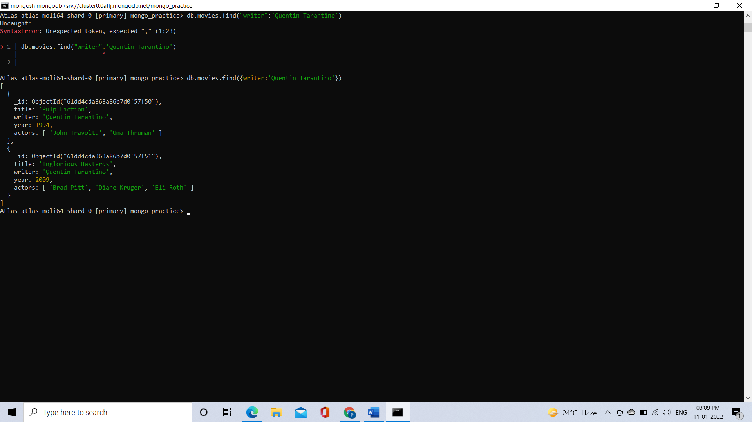

**3. get all documents where actors include "Brad Pitt"**

Command: db.movies.find({“actors”:’Brad Pitt’})

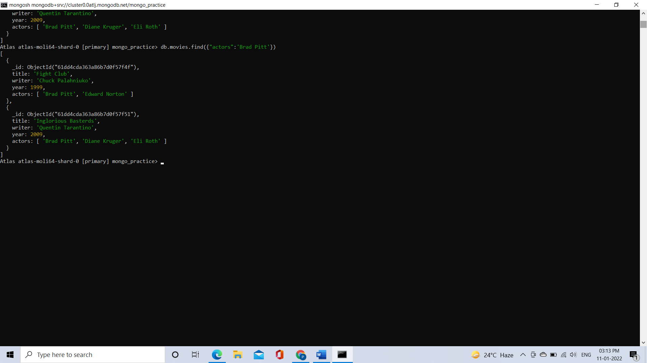

**4. get all documents with franchise set to "The Hobbit"**

Command: db.movies.find({franchise:’The Hobbit’})

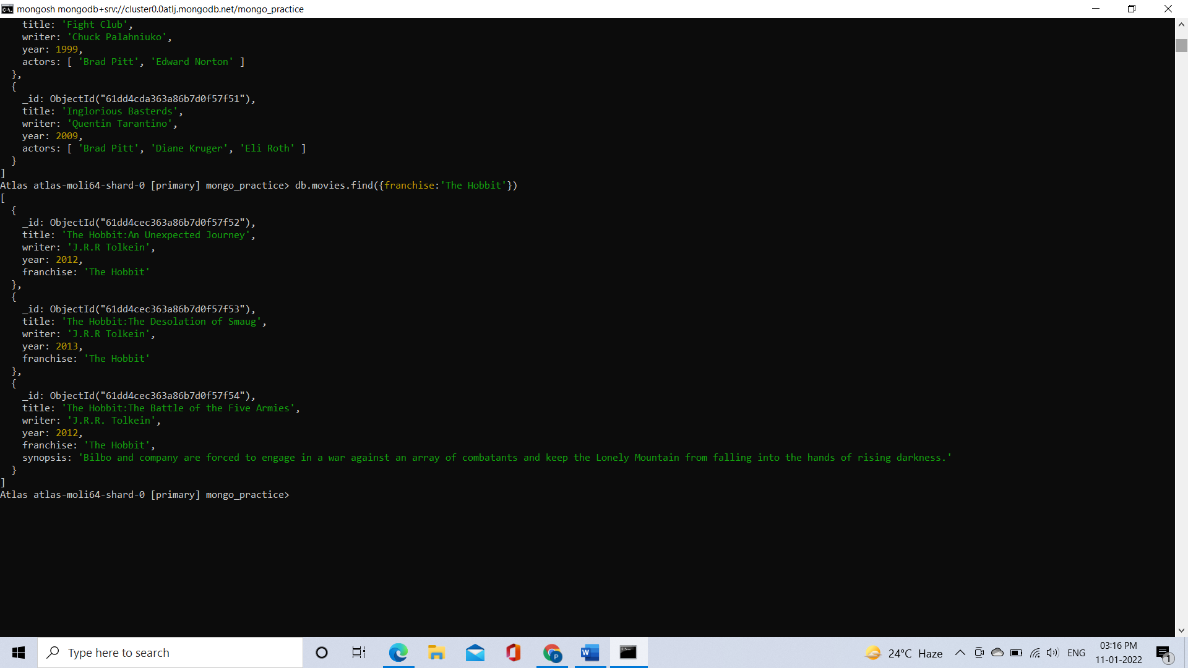

**5. get all movies released in the 90s**

Command: db.movies.find({year:{$lt:2000}})

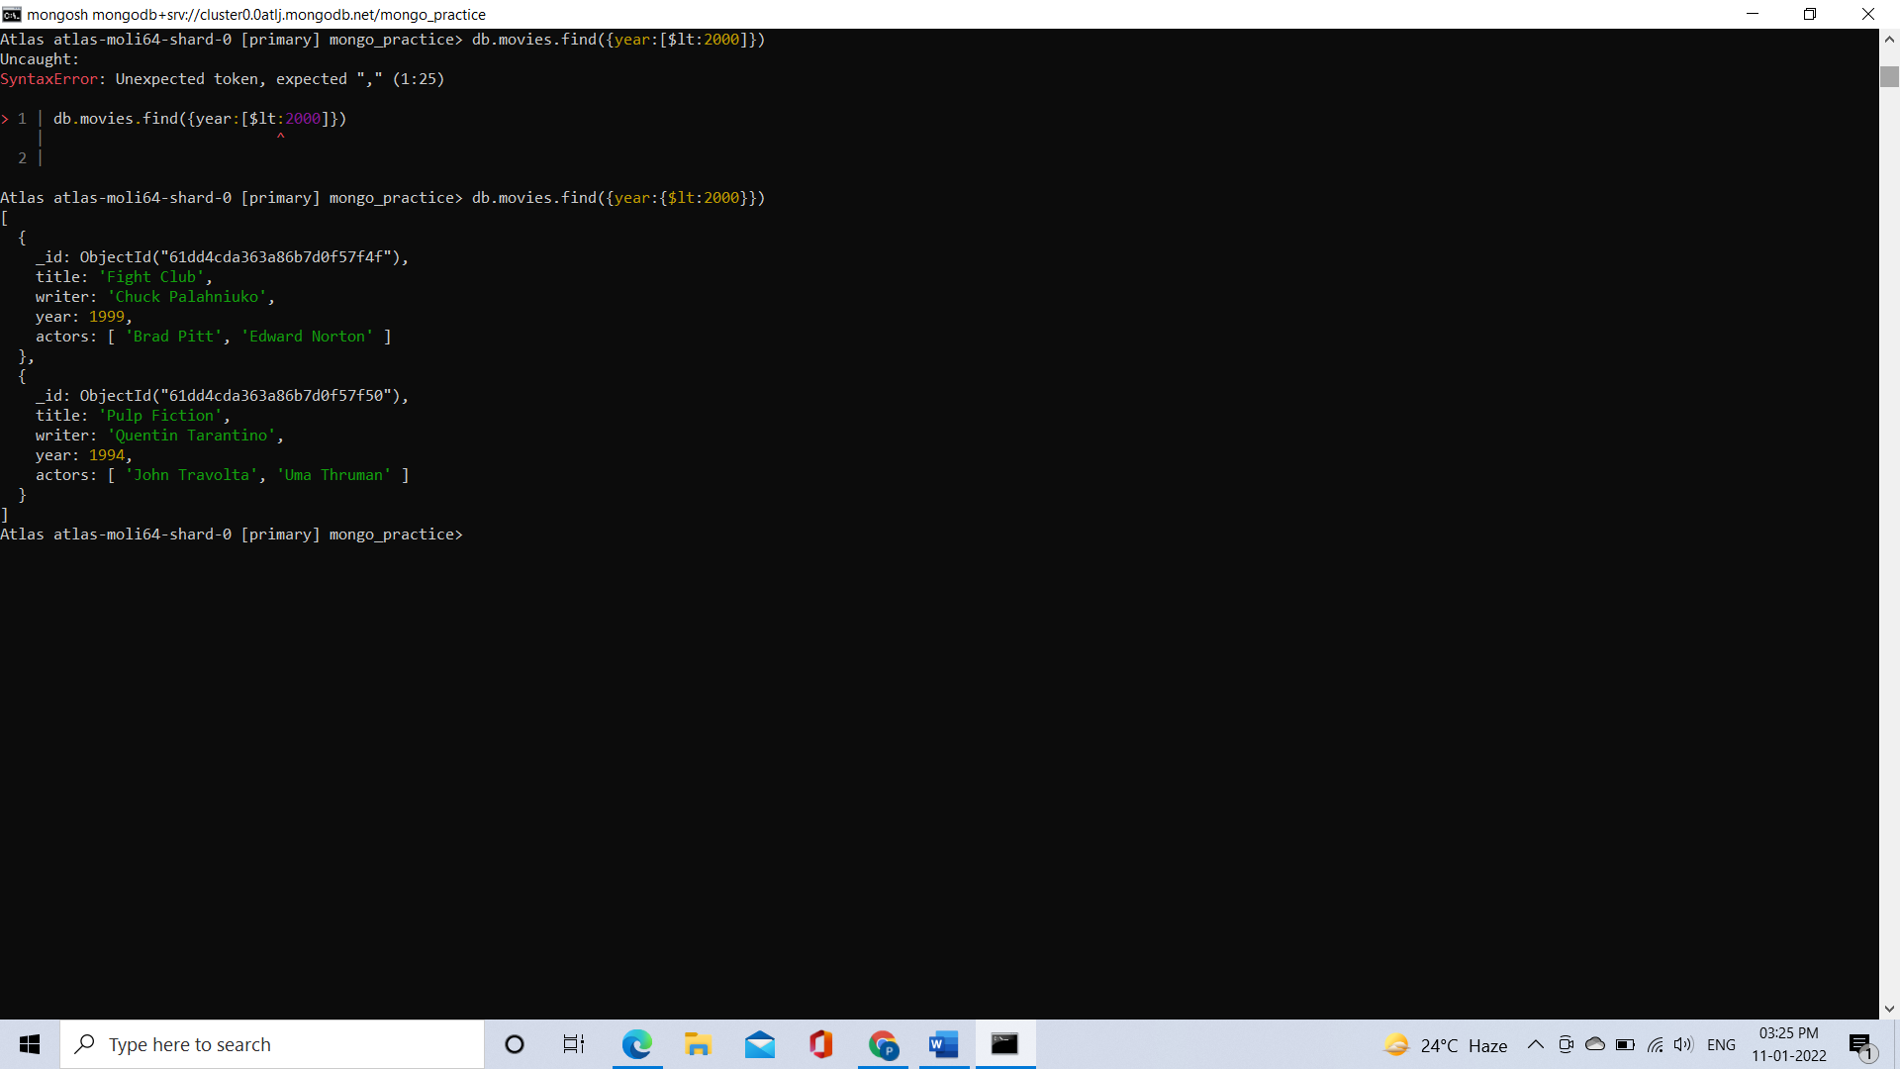

**6. get all movies released before the year 2000 or after 2010**

Command: db.movies.find({ $or:[{year:{$lt:2000}},{year:{$gt:2010}}] })

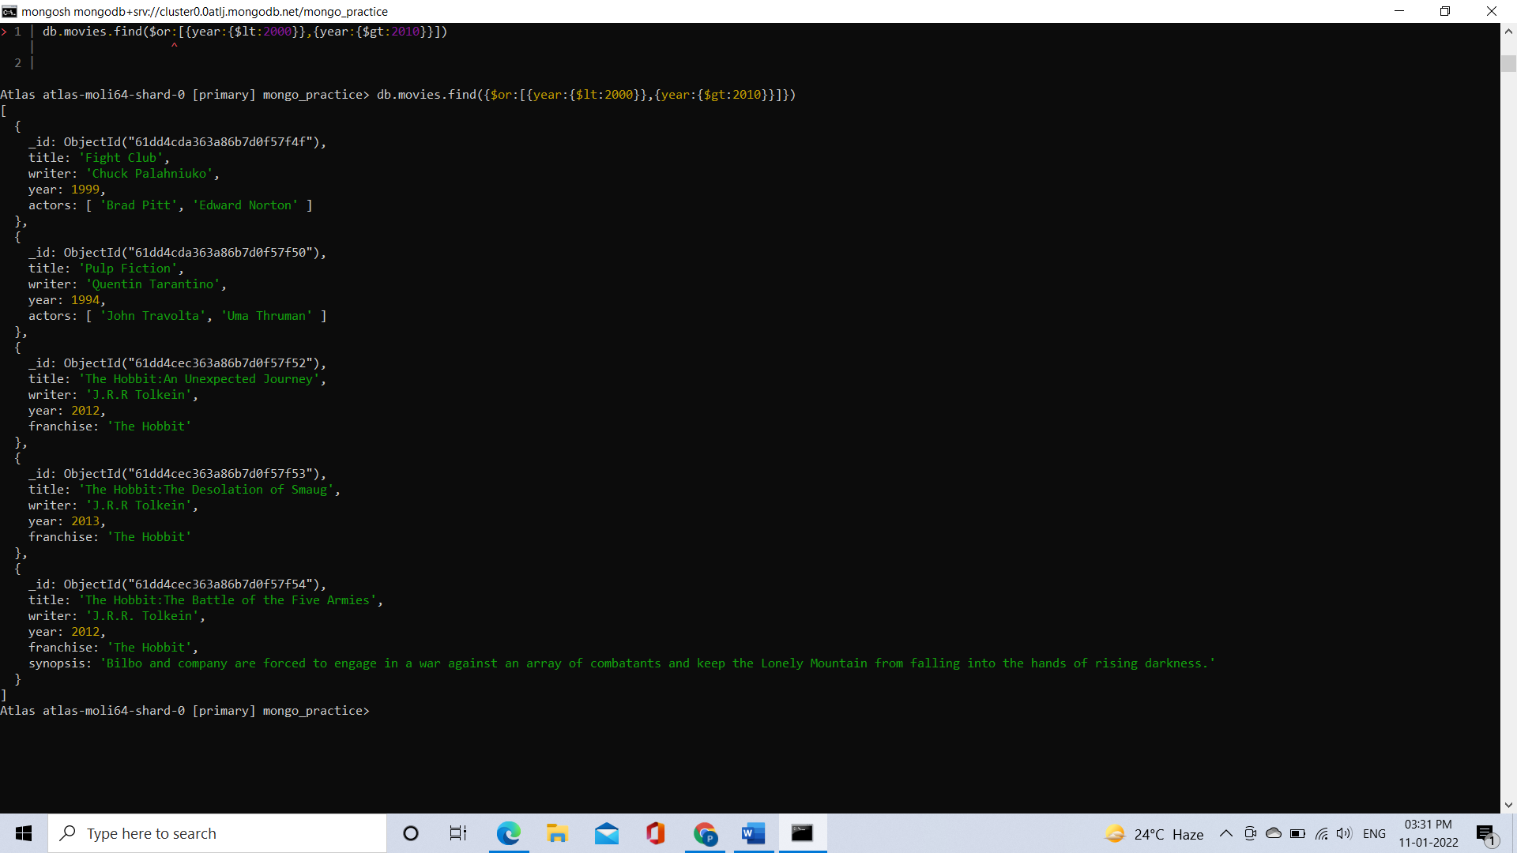

**Update Documents**

**1. add a synopsis to "The Hobbit: An Unexpected Journey" : "A reluctant hobbit, Bilbo Baggins, sets out to the Lonely Mountain with a spirited group of dwarves to reclaim their mountain home - and the gold within it - from the dragon Smaug."**

Command: db.movies.update({title:’The Hobbit: An Unexpected Journey’},{$set:{synopsis:’ A reluctant hobbit, Bilbo Baggins, sets out to the Lonely Mountain with a spirited group of dwarves to reclaim their mountain home - and the gold within it - from the dragon Smaug.’}})

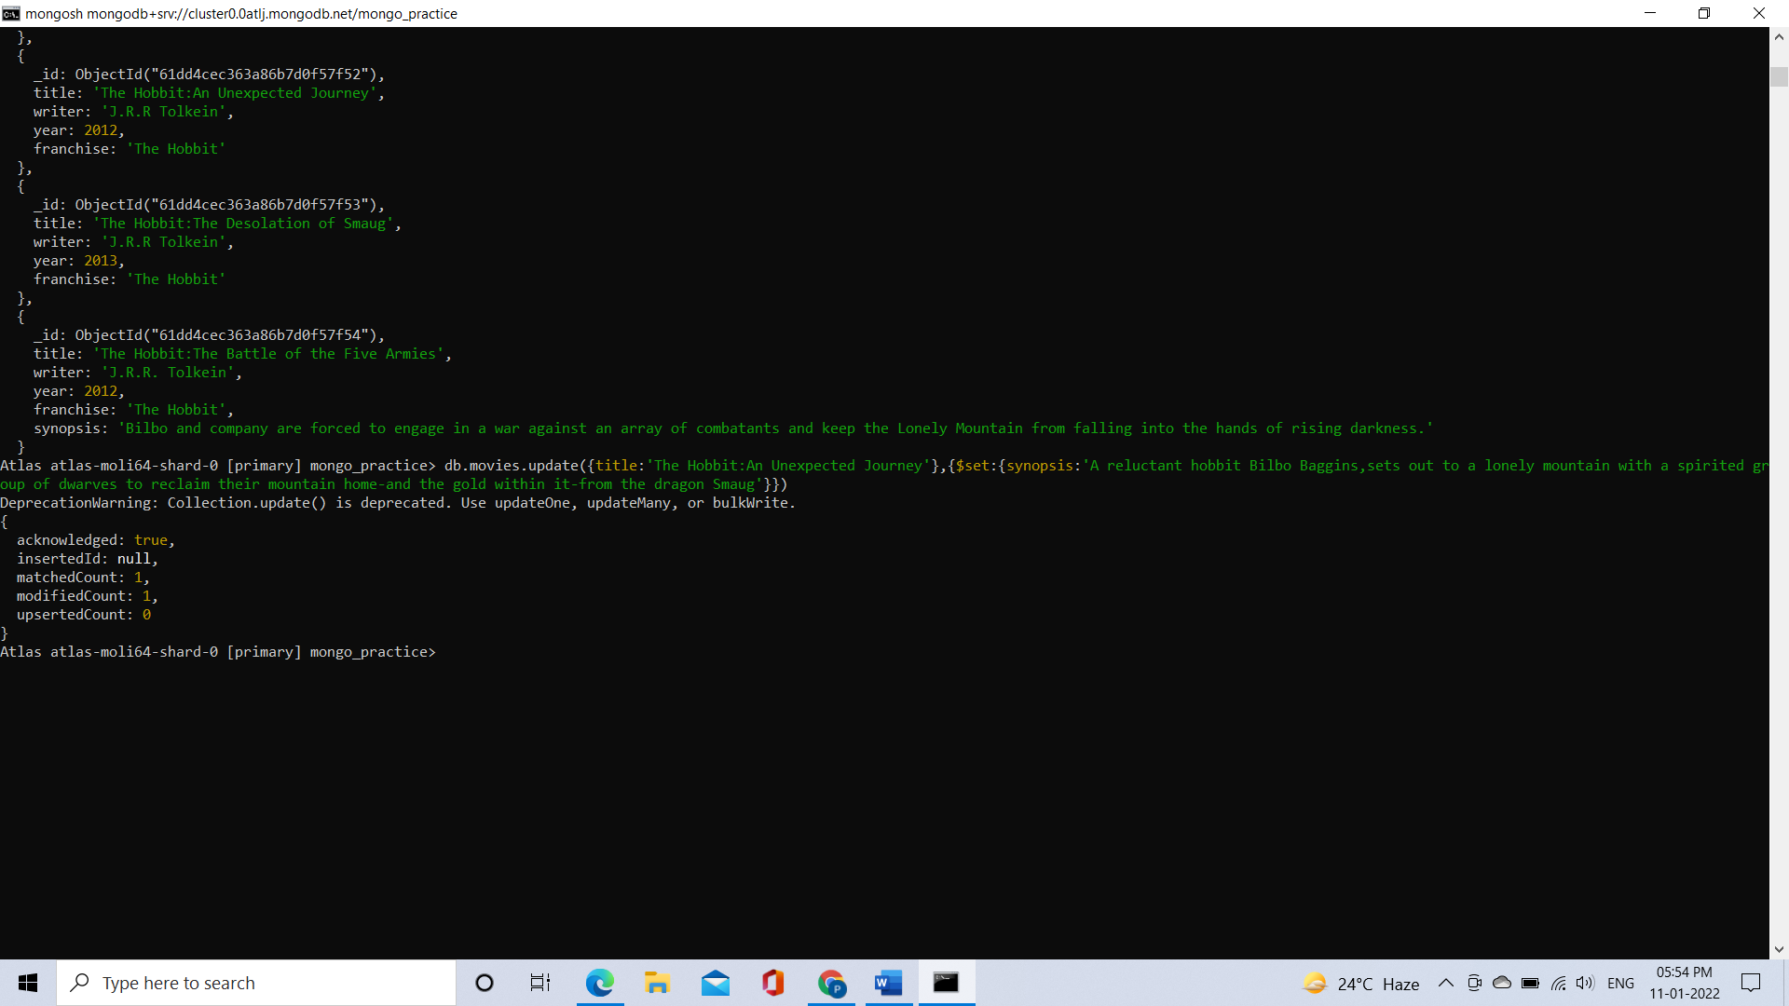

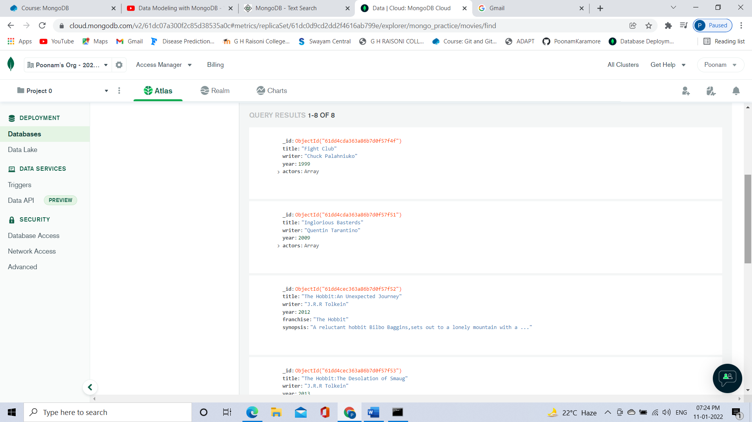

**2. add a synopsis to "The Hobbit: The Desolation of Smaug" : "The dwarves, along with Bilbo Baggins and Gandalf the Grey, continue their quest to reclaim Erebor, their homeland, from Smaug. Bilbo Baggins is in possession of a mysterious and magical ring."**

Command: db.movies.update({title:’ The Hobbit: The Desolation of Smaug’},{$set:{synopsis:’ The dwarves, along with Bilbo Baggins and Gandalf the Grey, continue their quest to reclaim Erebor, their homeland, from Smaug. Bilbo Baggins is in possession of a mysterious and magical ring.’}})

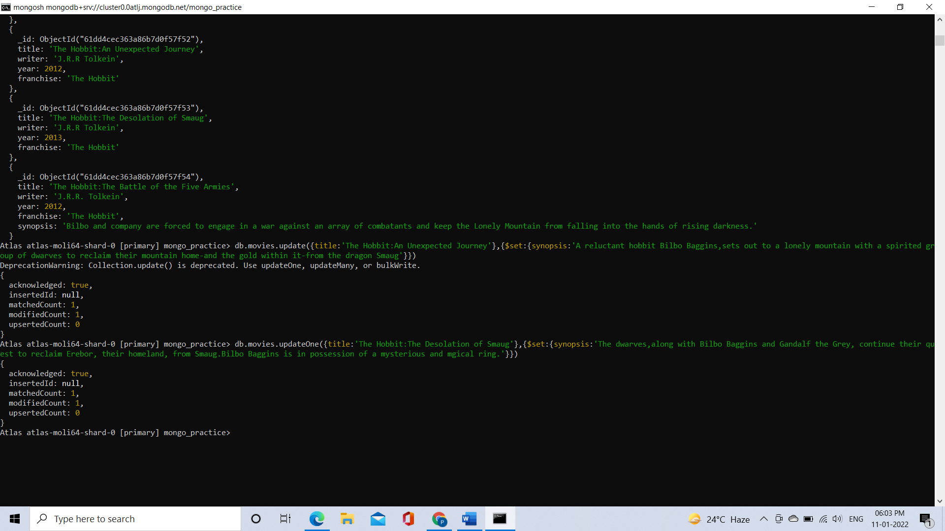

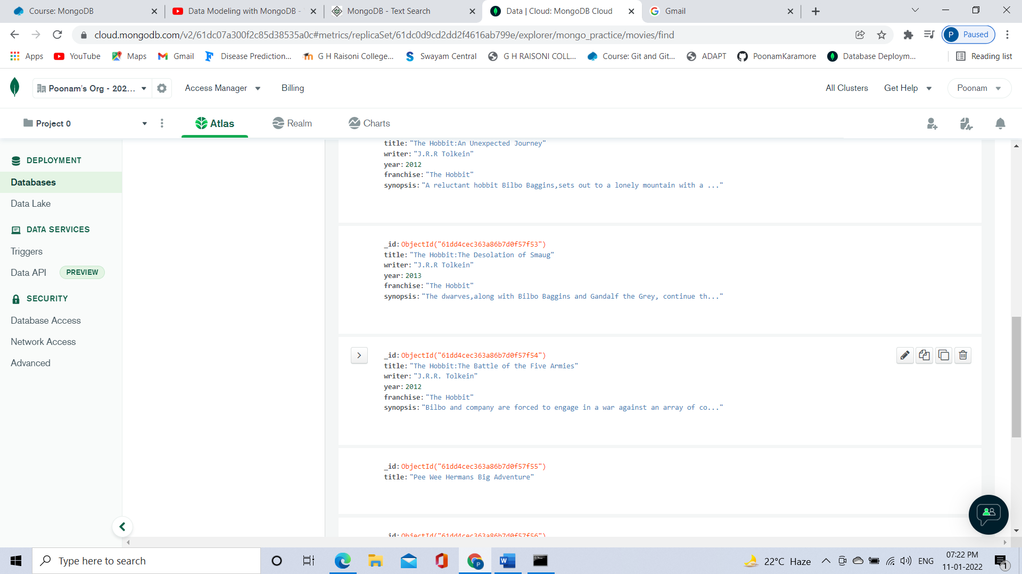

**3. add an actor named "Samuel L. Jackson" to the movie "Pulp Fiction"**

Command: db.movies.updateOne({title:’Pulp Fiction’},{$set:{‘actors.2’:’Samuel L. Jackson’}})

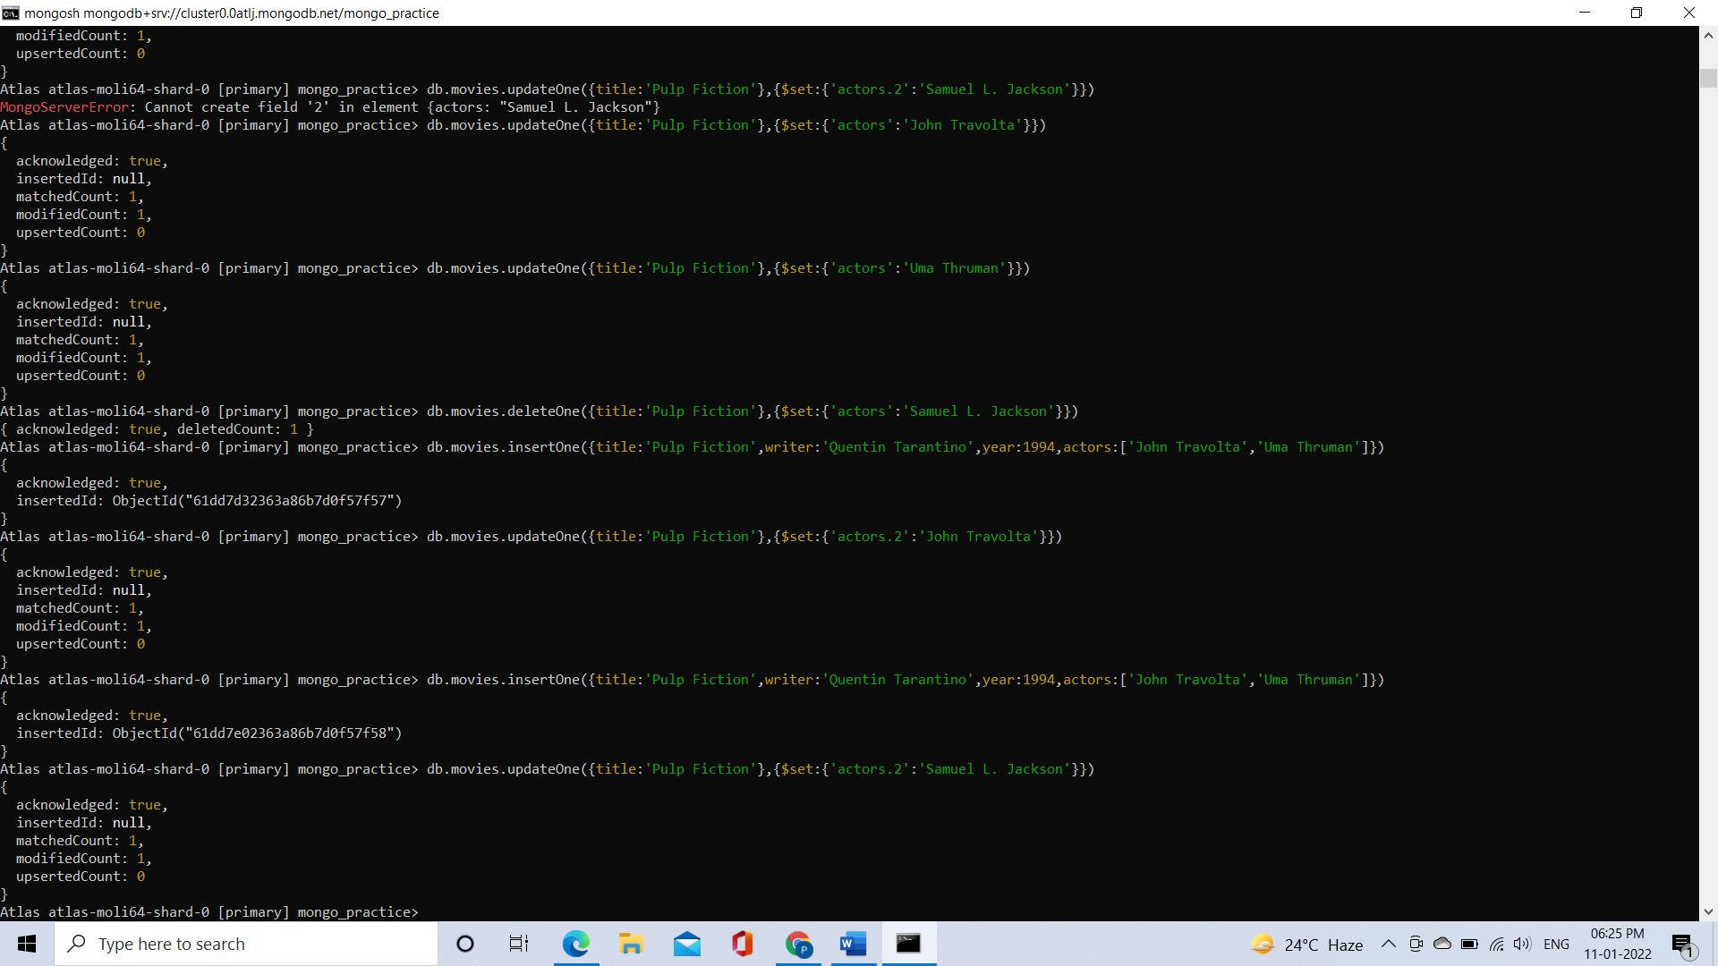

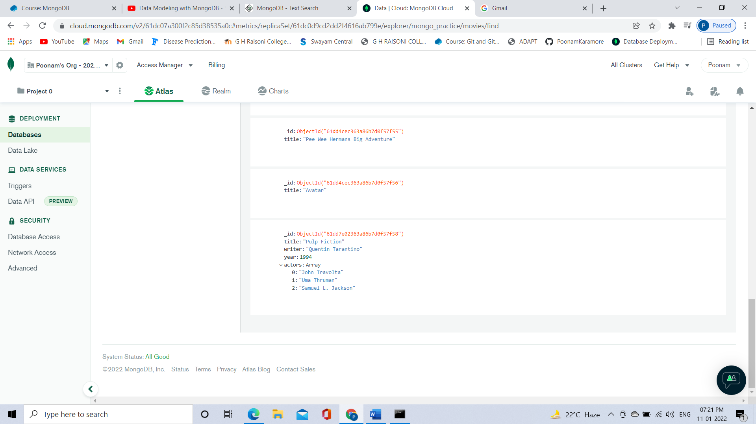

**Text Search**

**1. find all movies that have a synopsis that contains the word "Bilbo"**

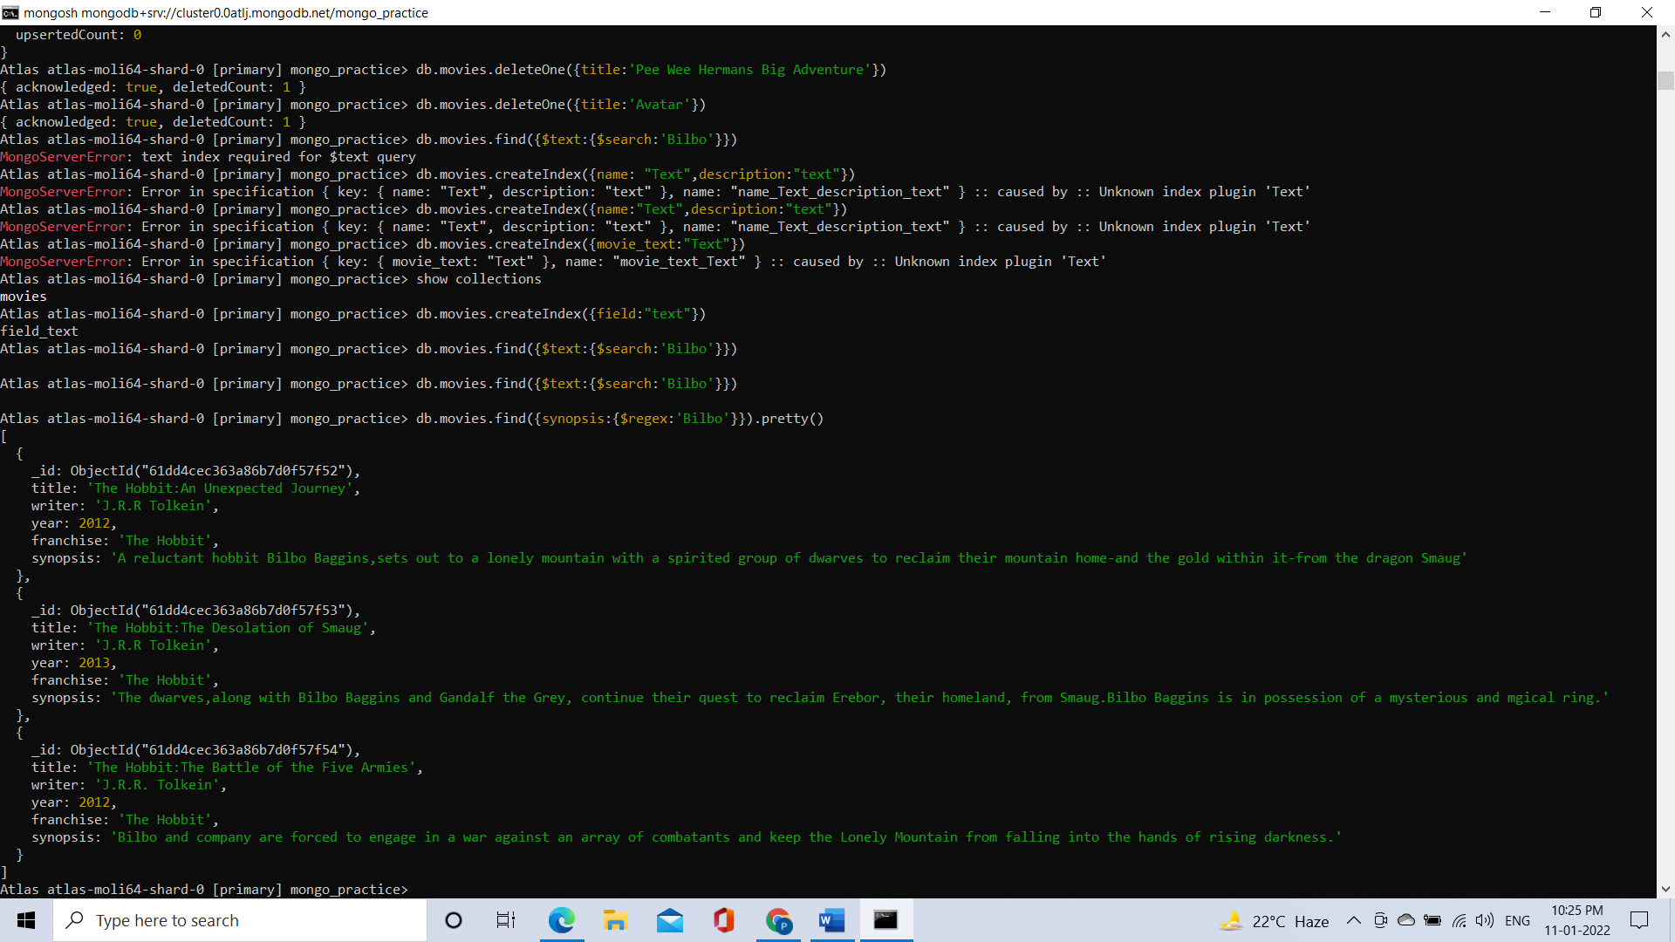

**2. find all movies that have a synopsis that contains the word "Gandalf"**

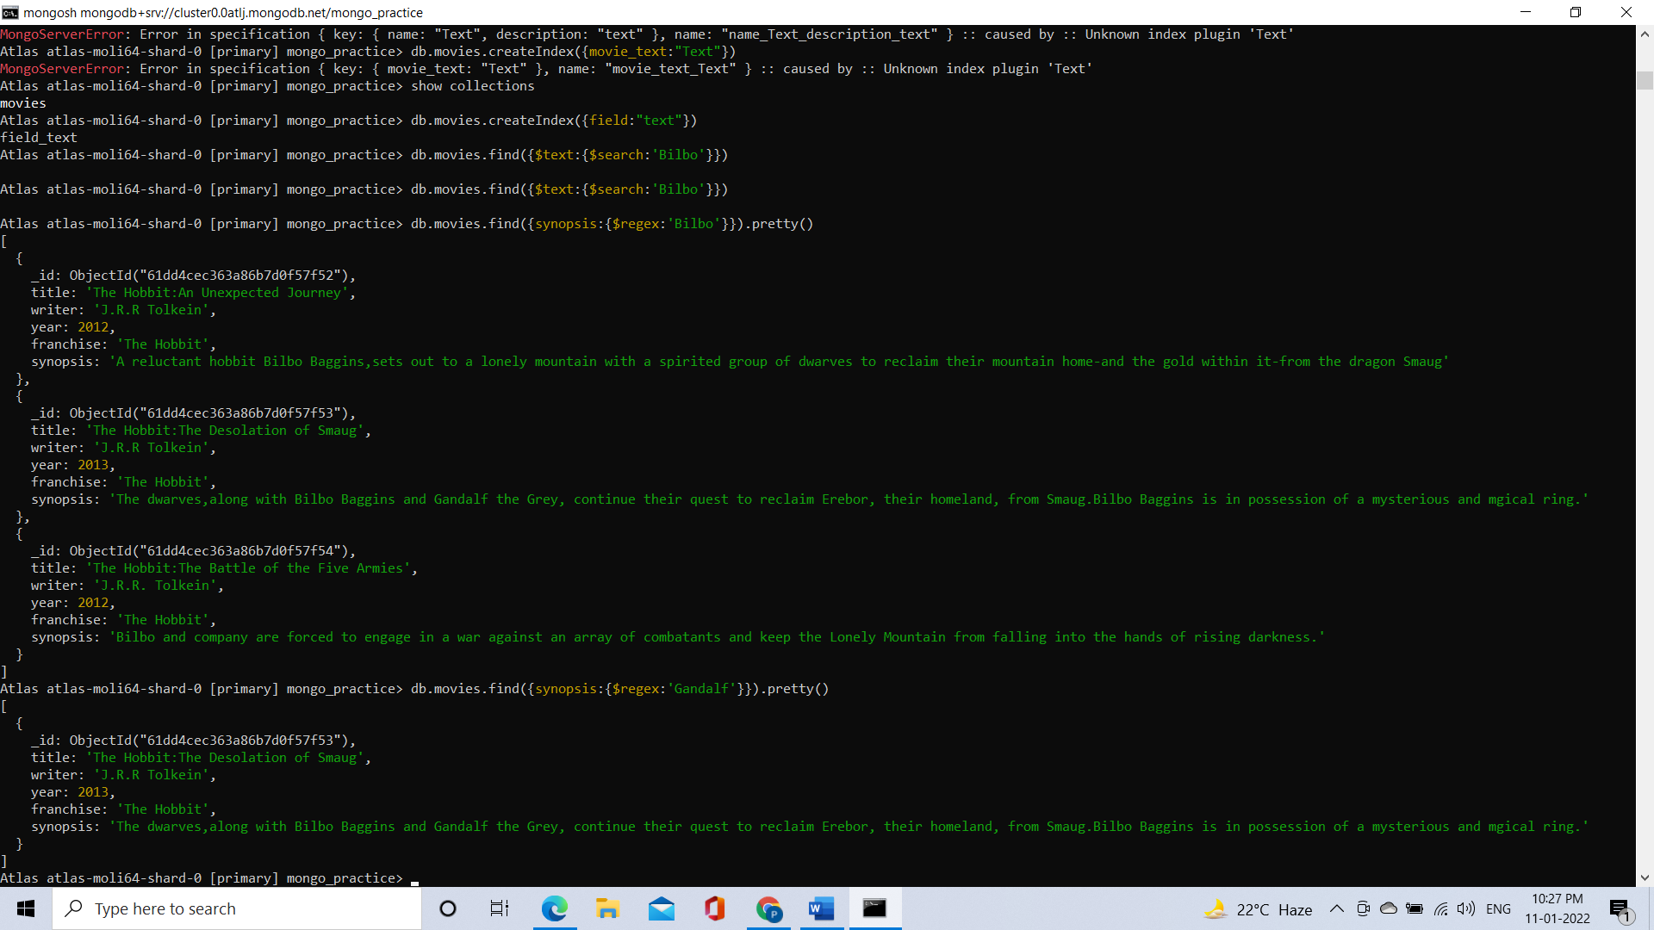

**3. find all movies that have a synopsis that contains the word "Bilbo" and not the word "Gandalf"**

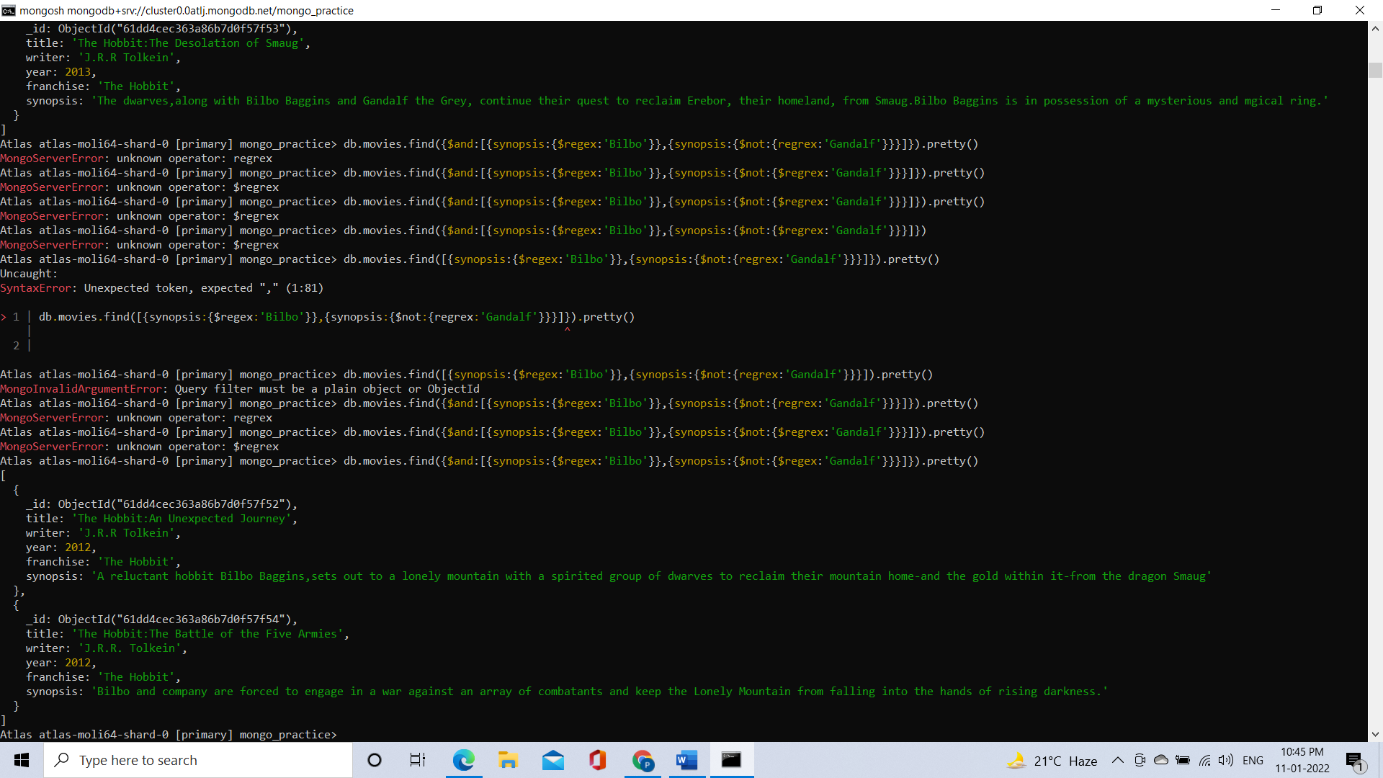

**4. find all movies that have a synopsis that contains the word "dwarves" or "hobbit"**

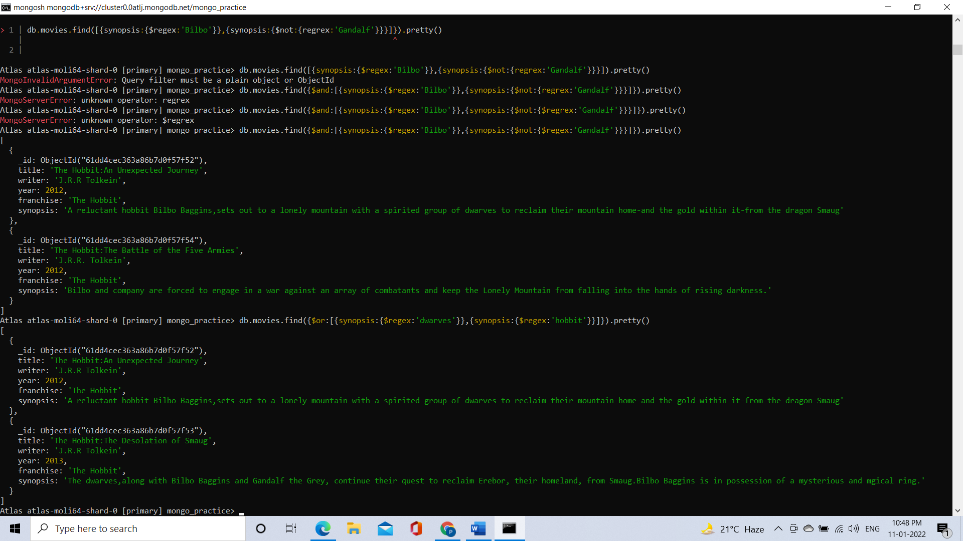

**5. find all movies that have a synopsis that contains the word "gold" and "dragon"**

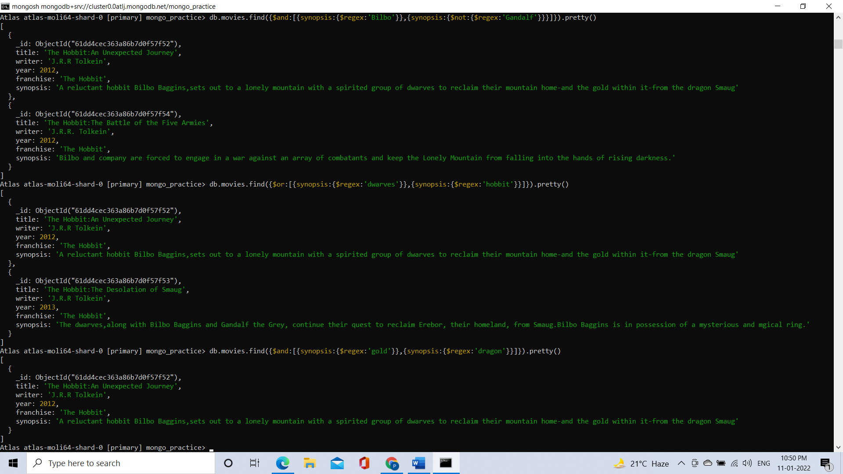

**Delete Documents**

**1. delete the movie "Pee Wee Hermans Big Adventure"**

Command: db.movies.deleteOne({title:’Pee Wee Hermans Big Adventure’})

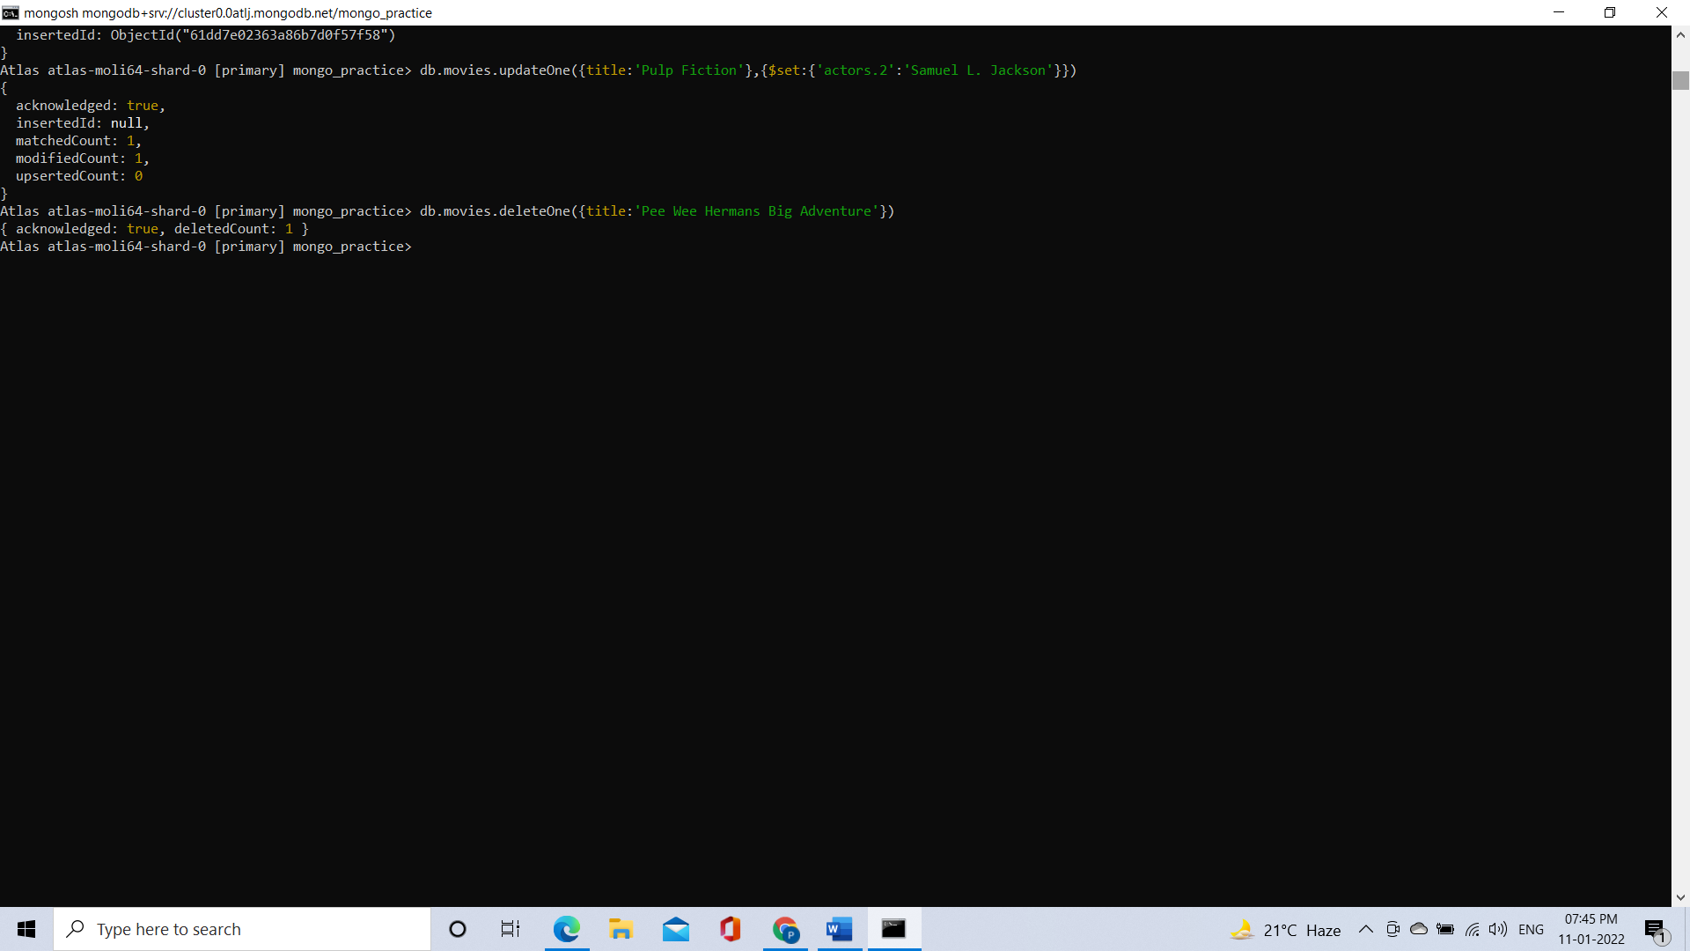

**2. delete the movie "Avatar"**

Command: db.movies.deleteOne({title:’Avatar’})

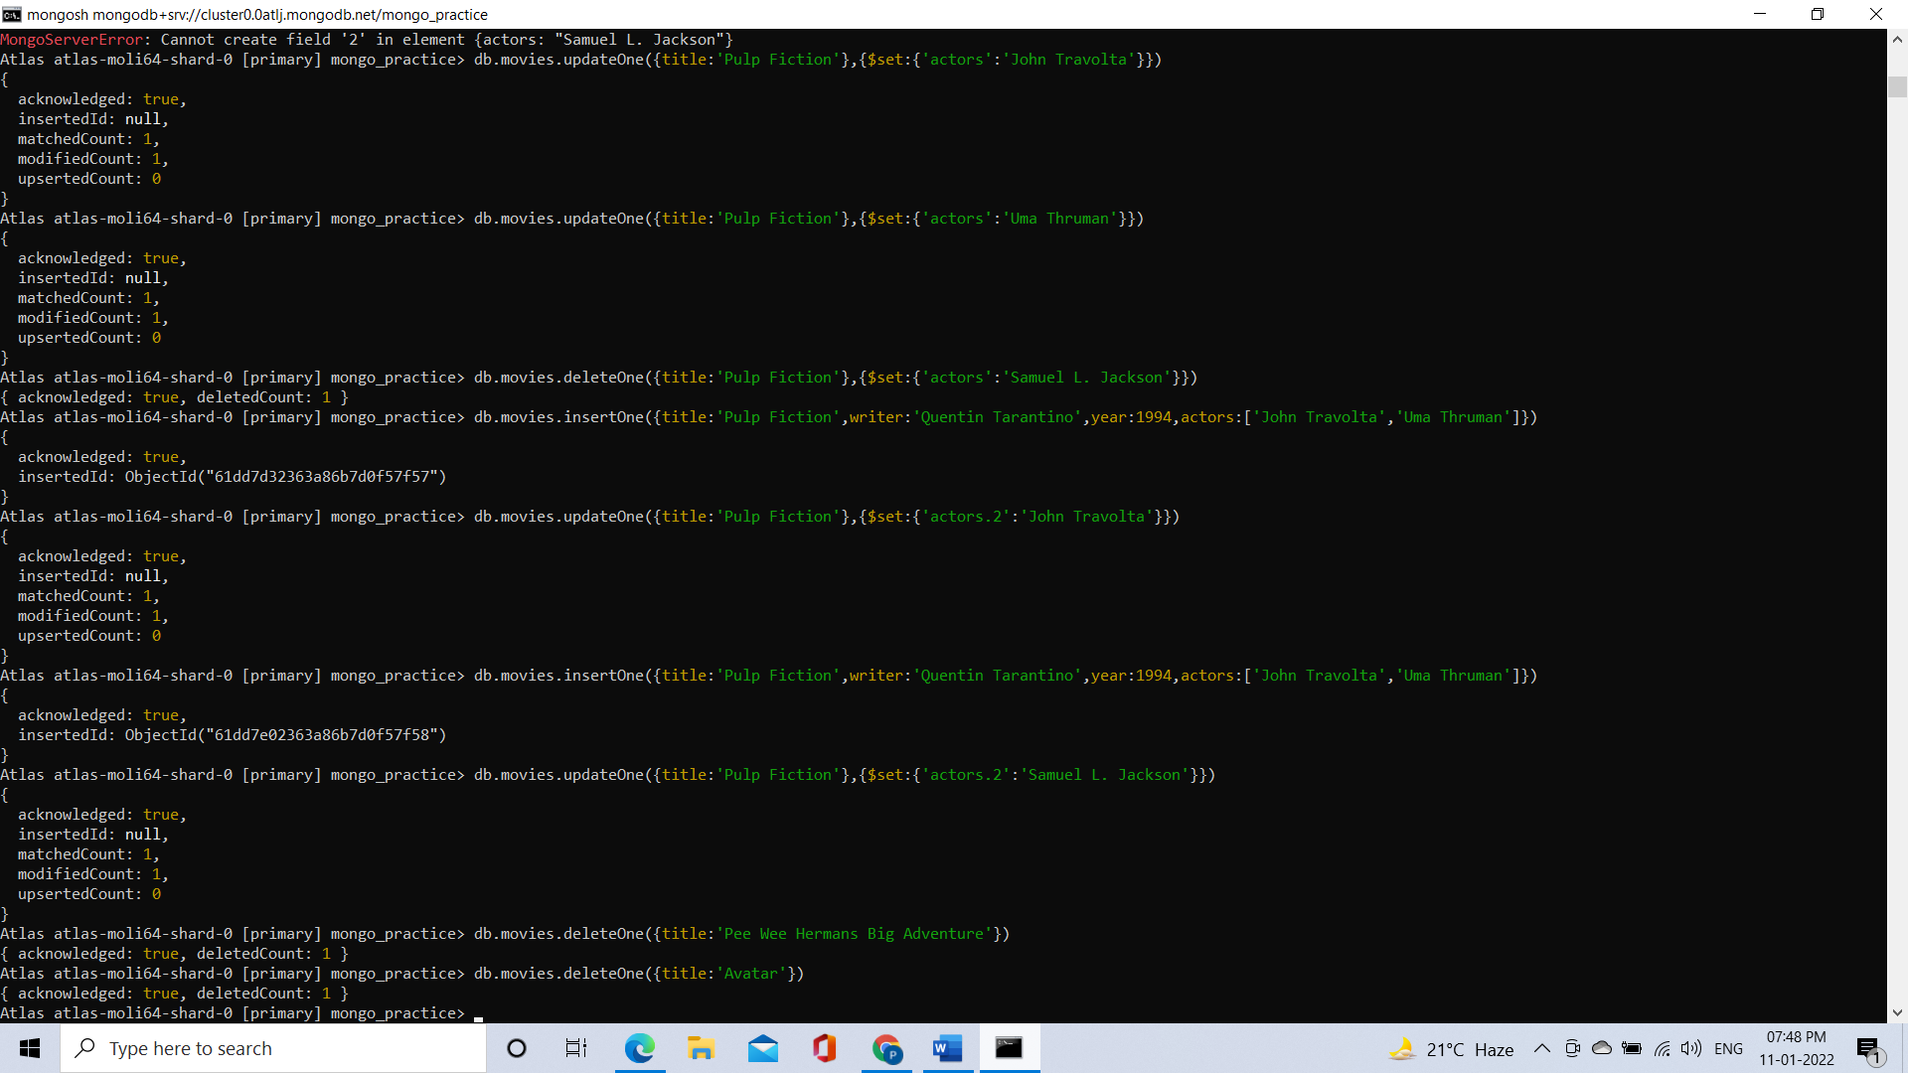

**Relationships**

**Insert the following documents into a users collection**

username : GoodGuyGreg first_name : "Good Guy" last_name : "Greg"

username : ScumbagSteve full_name : first : "Scumbag" last : "Steve"

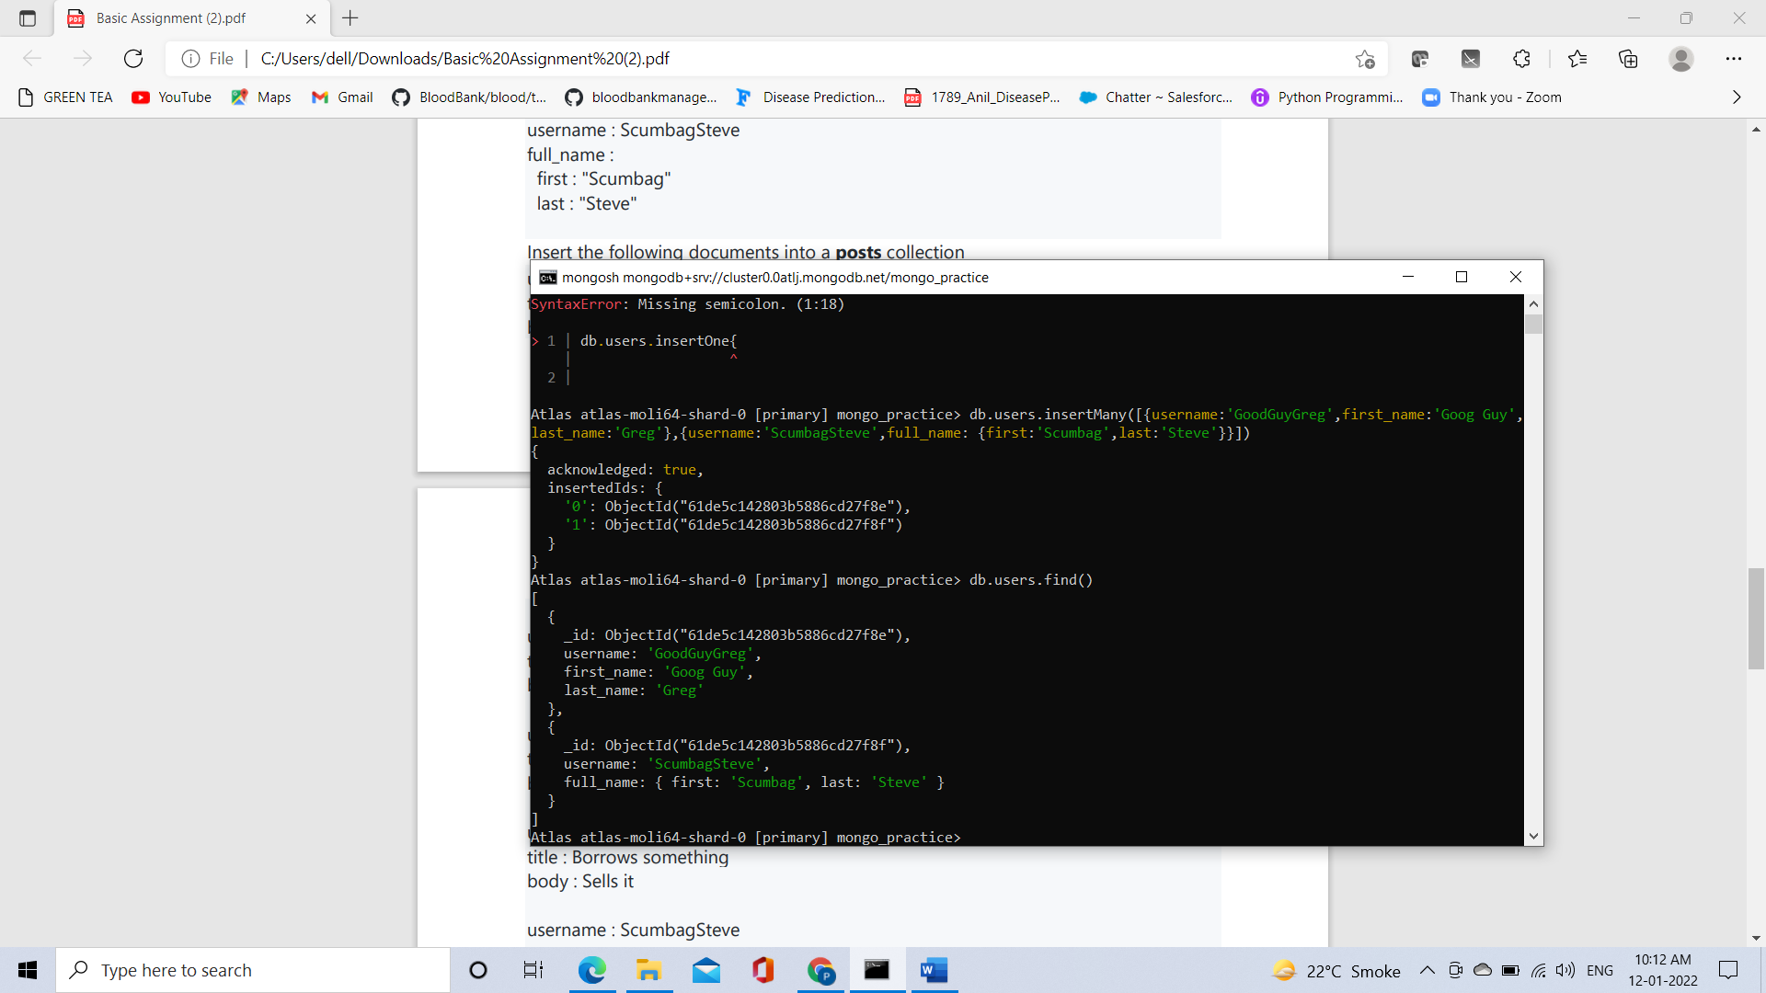

**Insert the following documents into a posts collection**

username : GoodGuyGreg title : Passes out at party body : Wakes up early and cleans house

username : GoodGuyGreg title : Steals your identity body : Raises your credit score

username : GoodGuyGreg title : Reports a bug in your code body : Sends you a Pull Request

username : ScumbagSteve title : Borrows something body : Sells it

username : ScumbagSteve title : Borrows everything body : The end

username : ScumbagSteve title : Forks your repo on github body : Sets to private

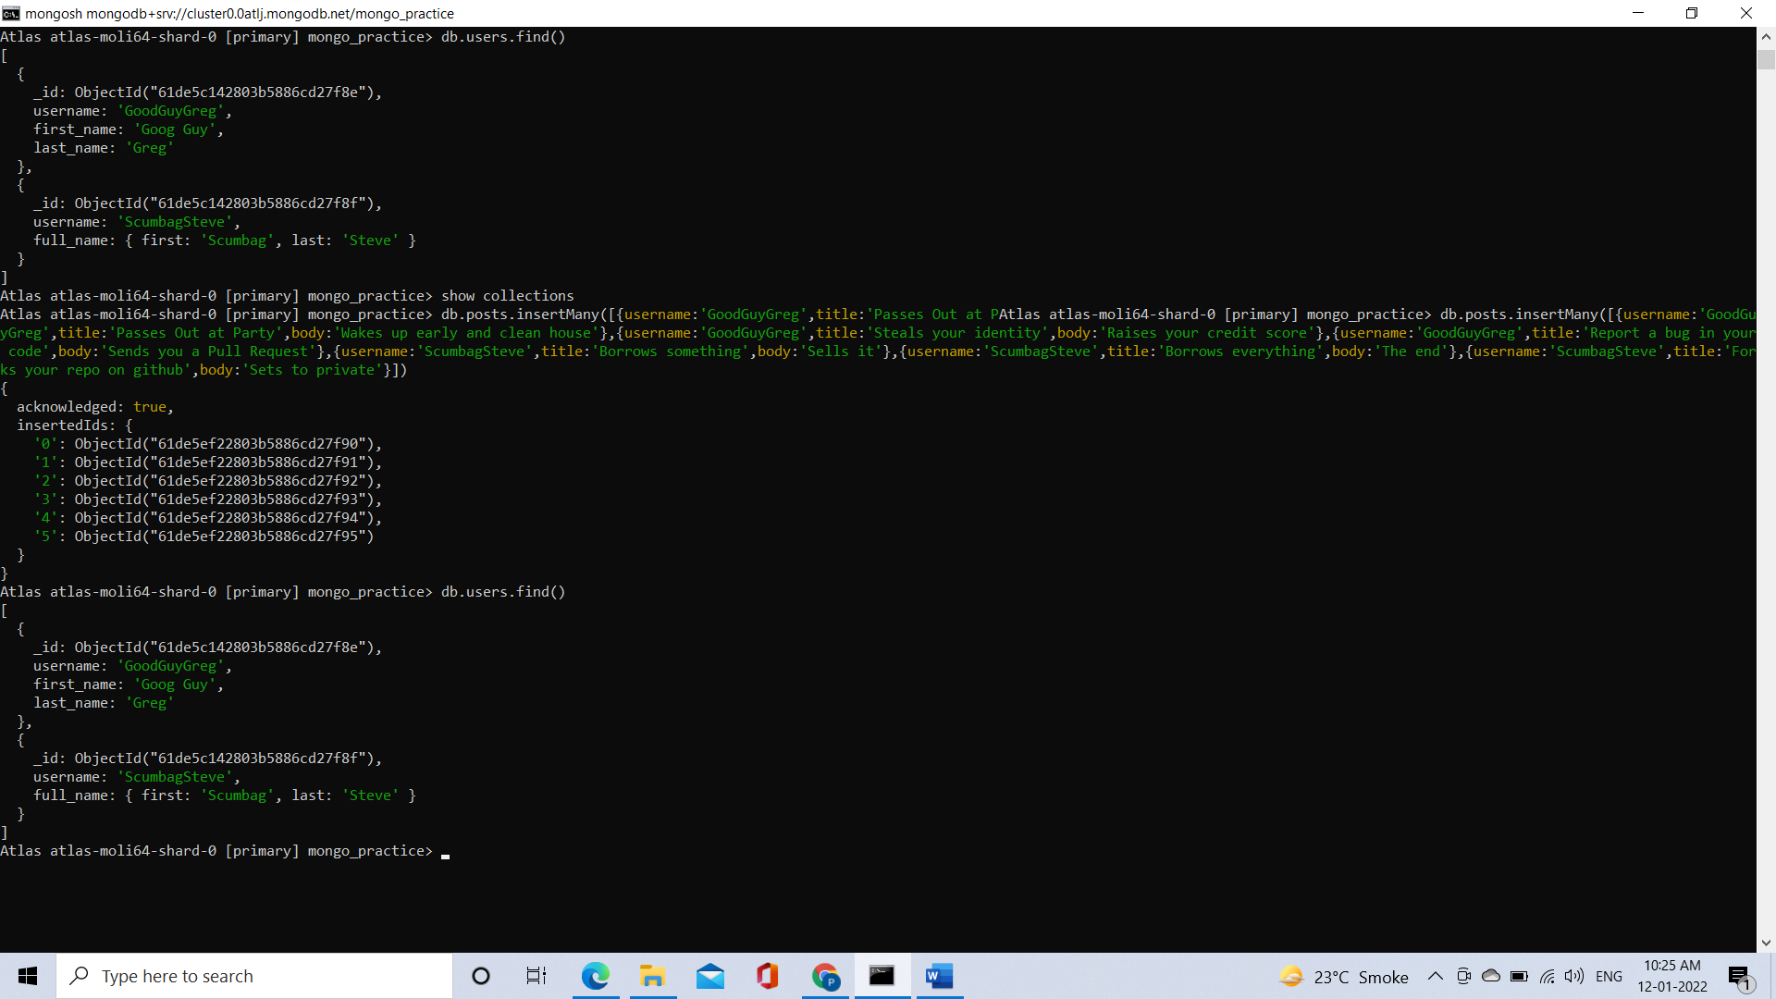

**Insert the following documents into a comments collection**

username : GoodGuyGreg comment : Hope you got a good deal! post : [post_obj_id] where [post_obj_id] is the ObjectId of the posts document: "Borrows something"

username : GoodGuyGreg comment : What's mine is yours! post : [post_obj_id] where [post_obj_id] is the ObjectId of the posts document: "Borrows everything"

username : GoodGuyGreg comment : Don't violate the licensing agreement! post : [post_obj_id] where [post_obj_id] is the ObjectId of the posts document: "Forks your repo on github

username : ScumbagSteve comment : It still isn't clean post : [post_obj_id] where [post_obj_id] is the ObjectId of the posts document: "Passes out at party"

username : ScumbagSteve comment : Denied your PR cause I found a hack post : [post_obj_id] where [post_obj_id] is the ObjectId of the posts document: "Reports a bug in your code"

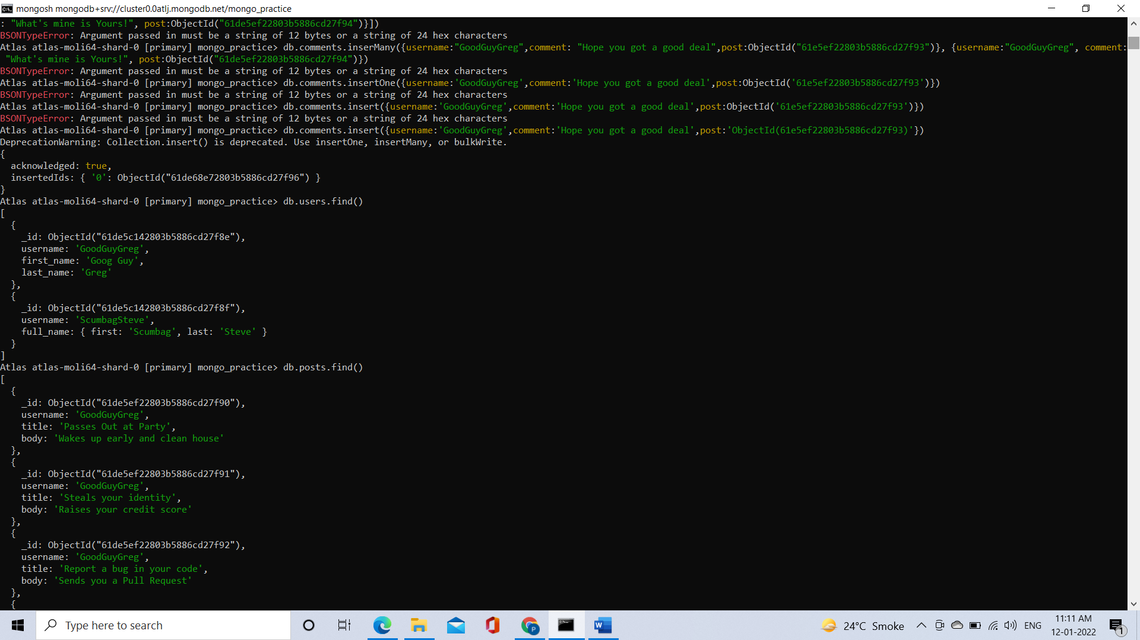

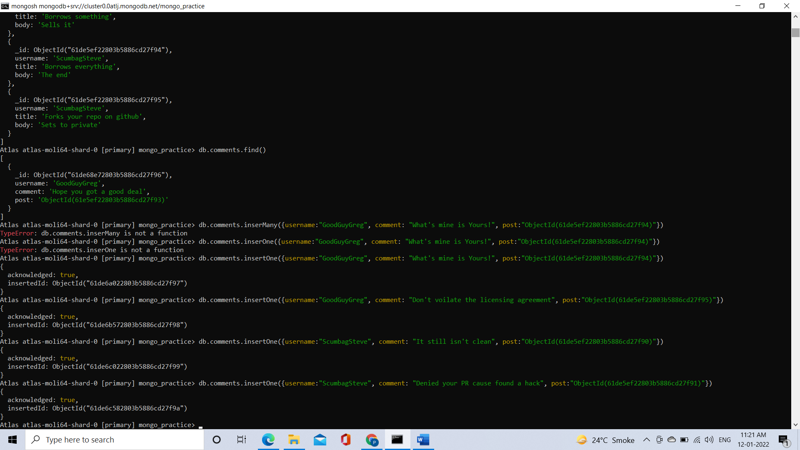

**1. find all users**

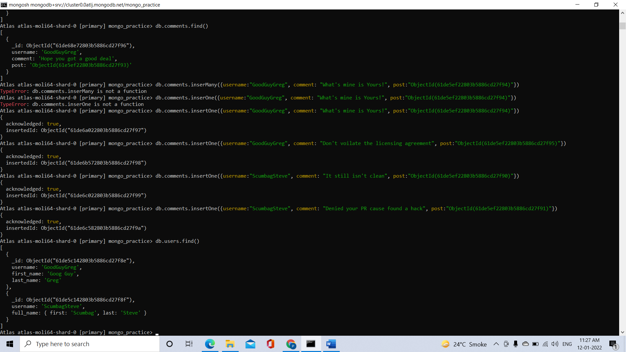

**2. find all posts**

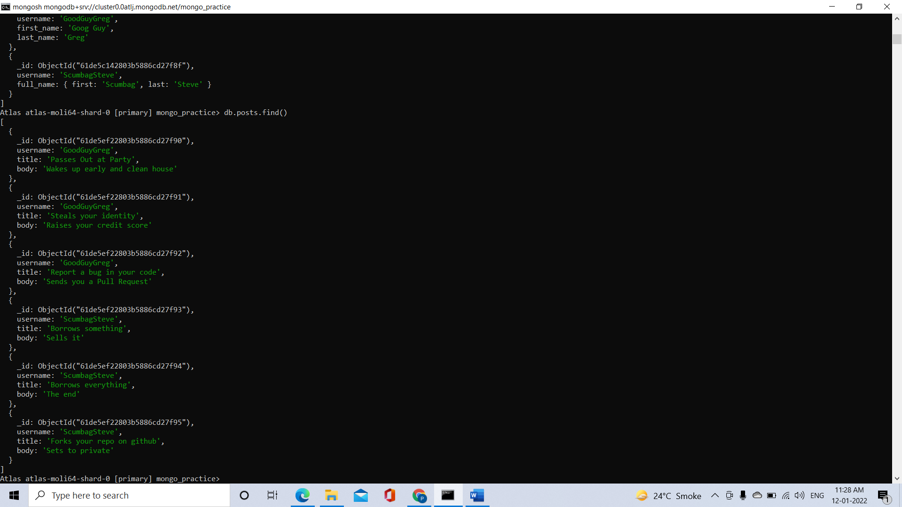

**3. find all posts that was authored by "GoodGuyGreg"**

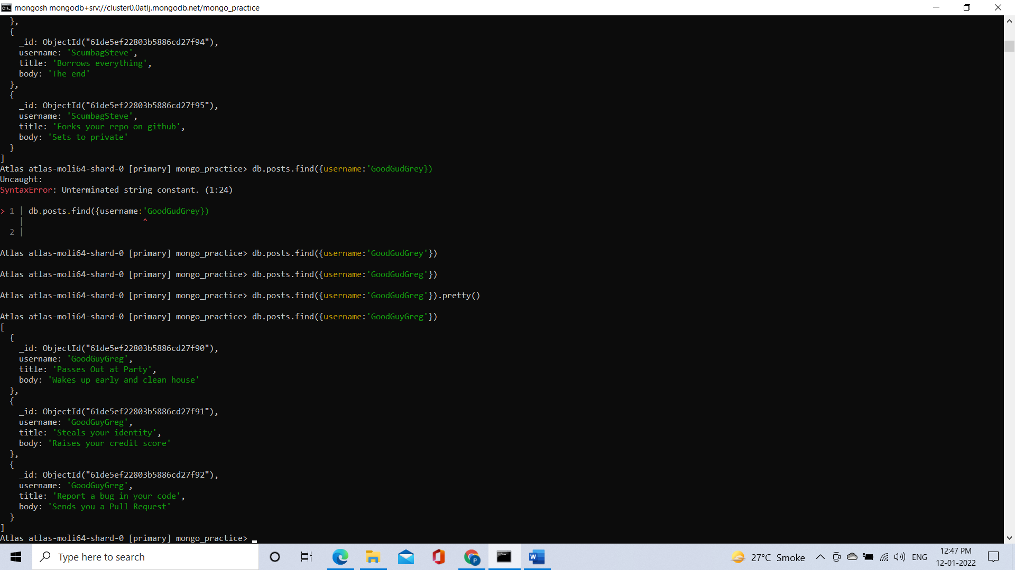

**4. find all posts that was authored by "ScumbagSteve"**

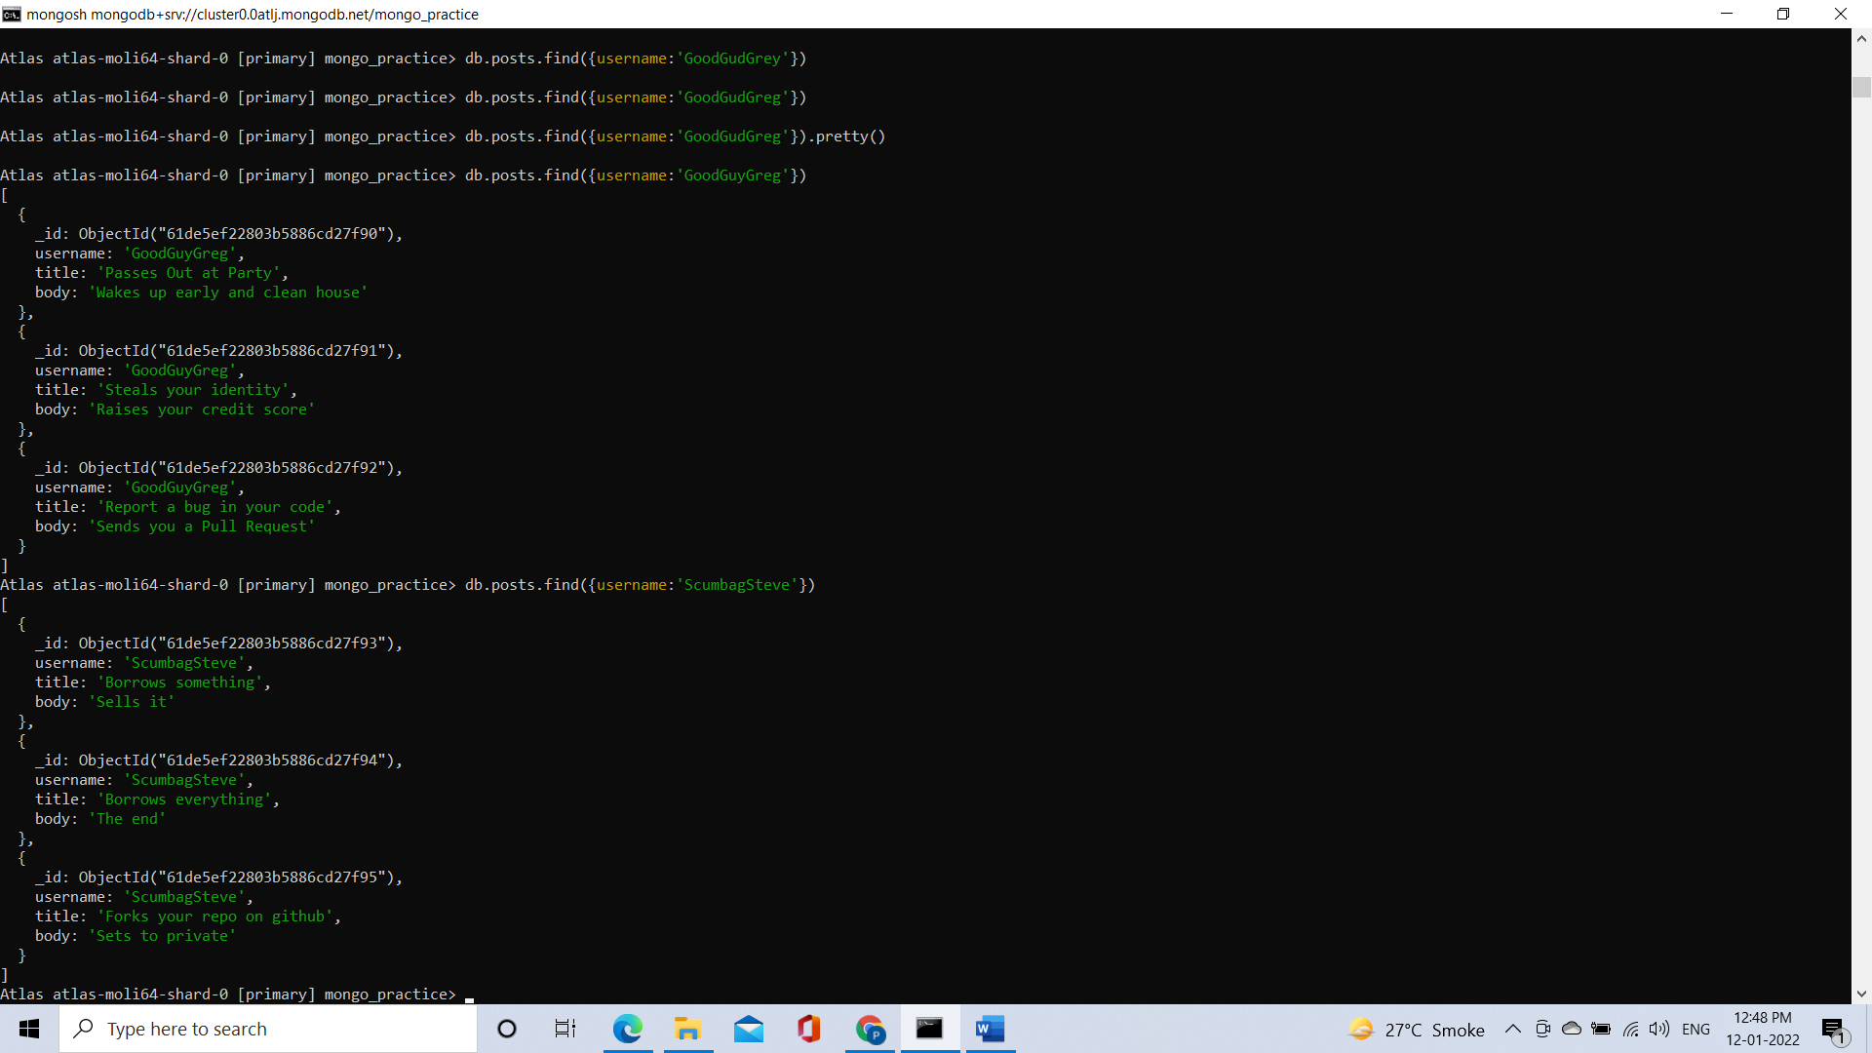

**5. find all comments**

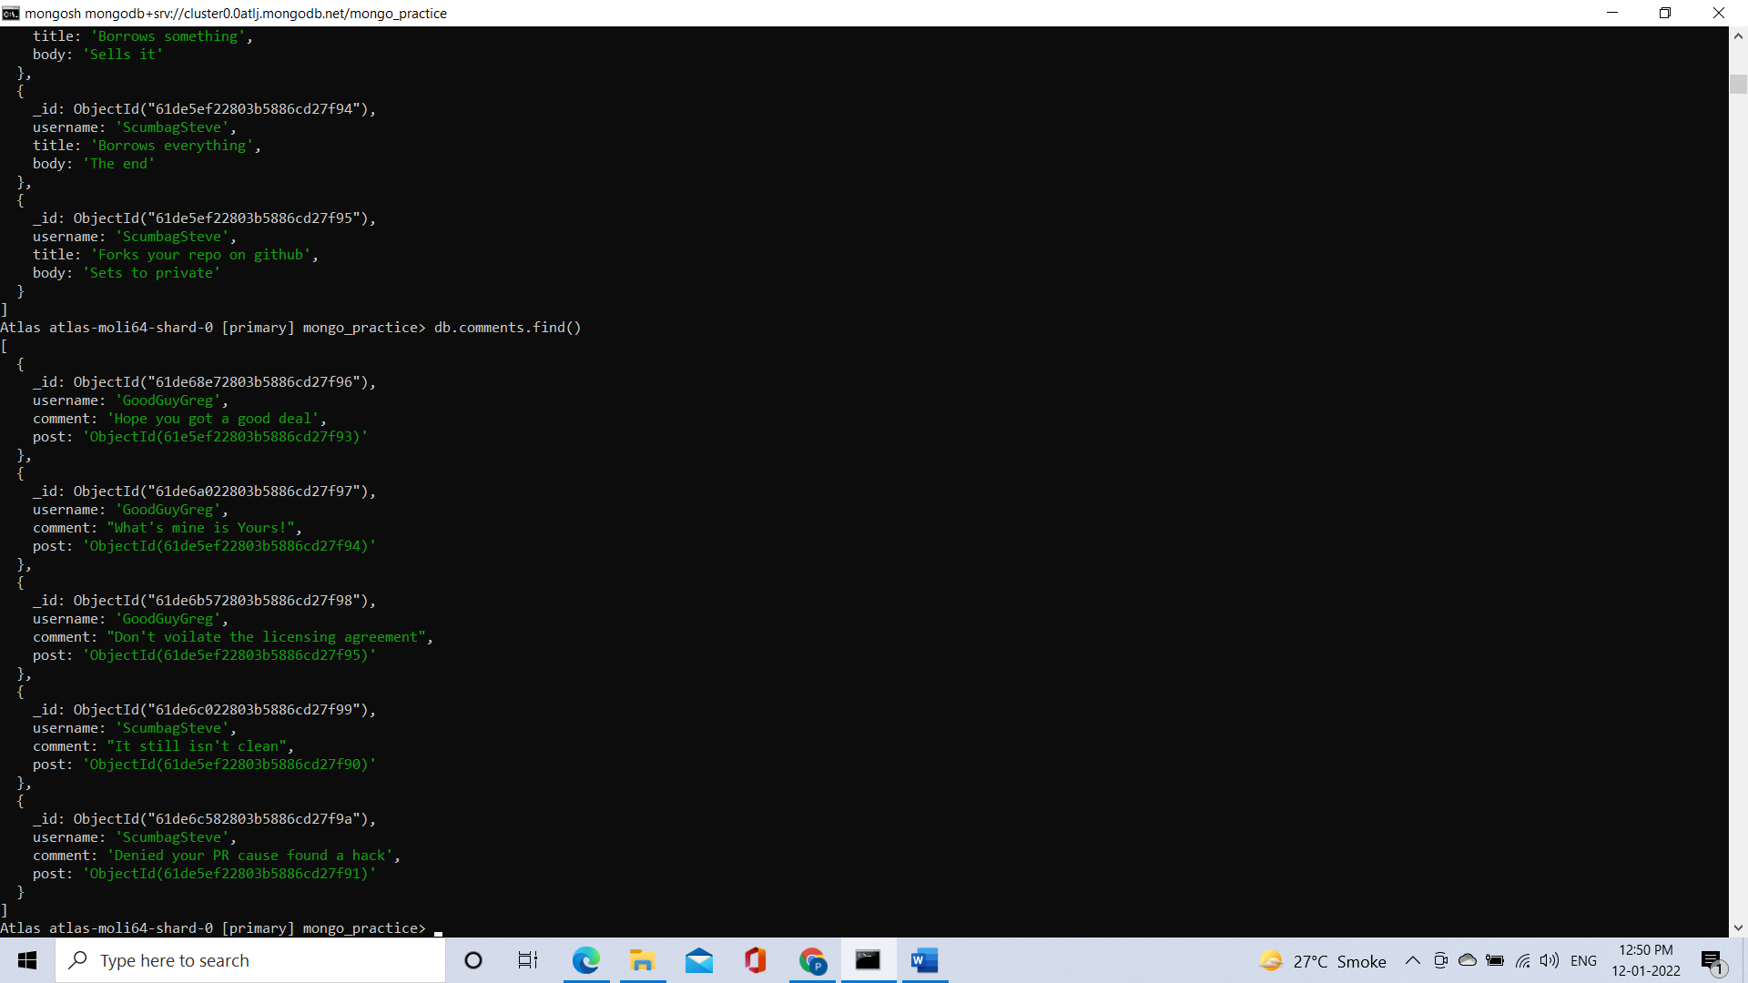

**6. find all comments that was authored by "GoodGuyGreg"**

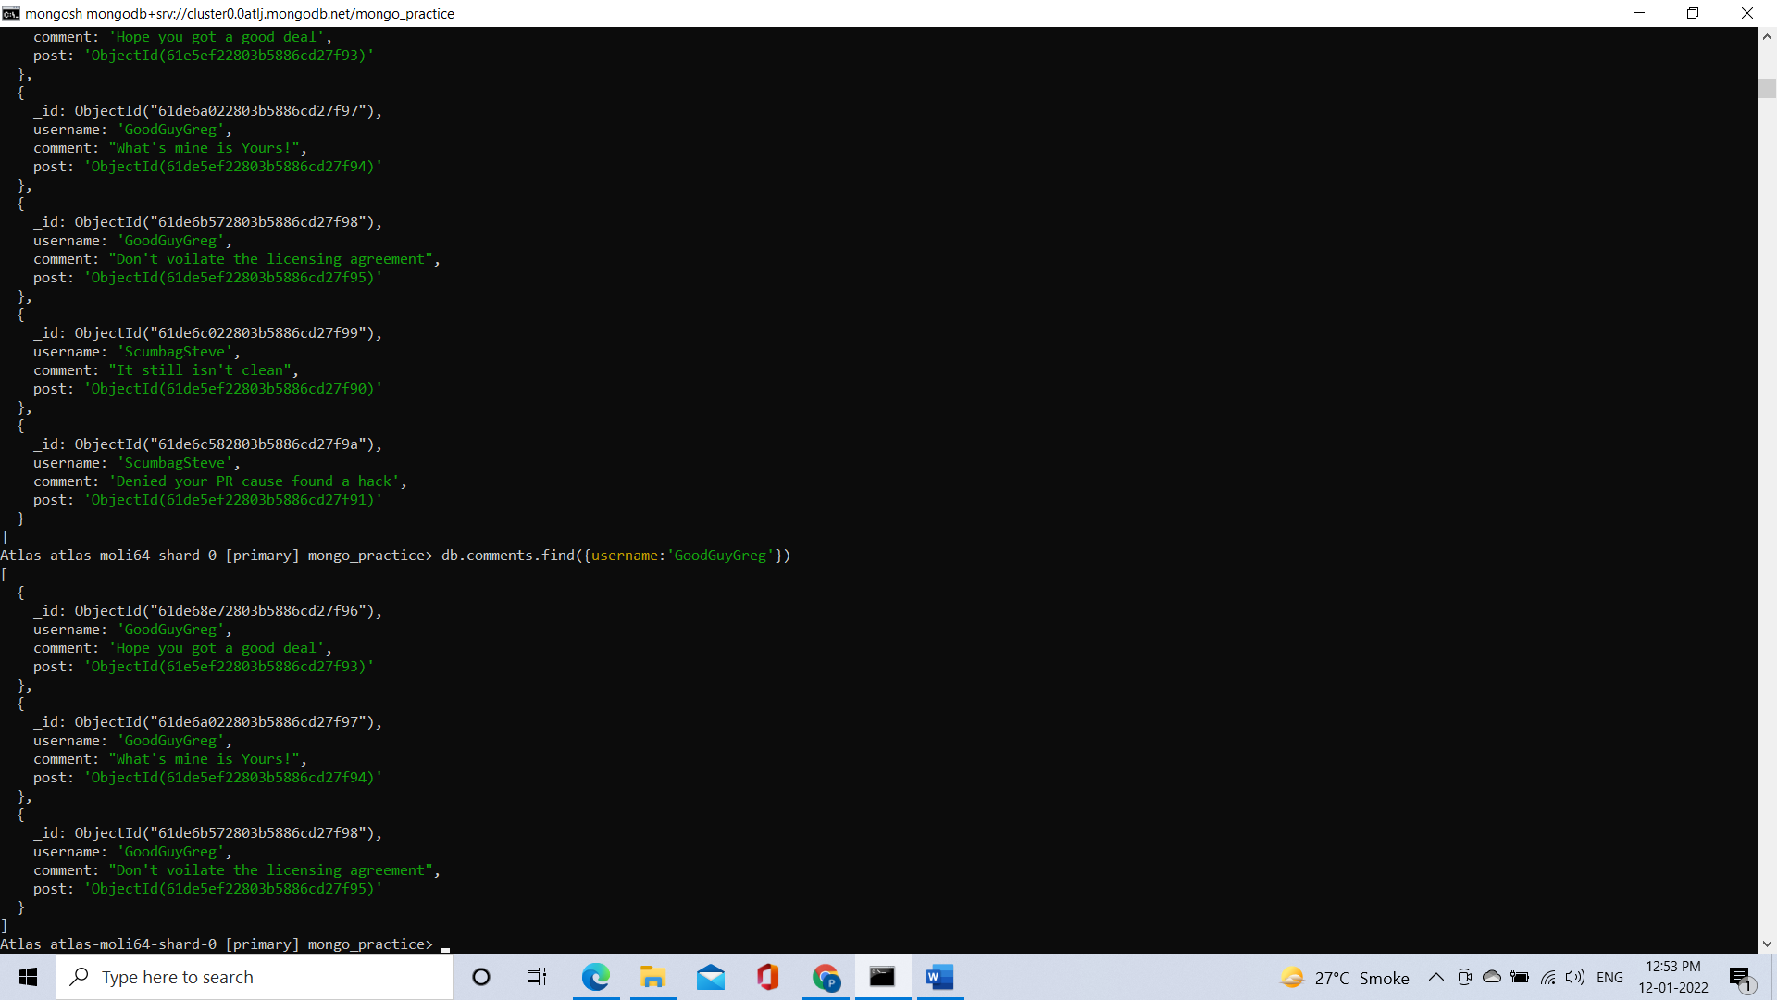

**7. find all comments that was authored by "ScumbagSteve"**

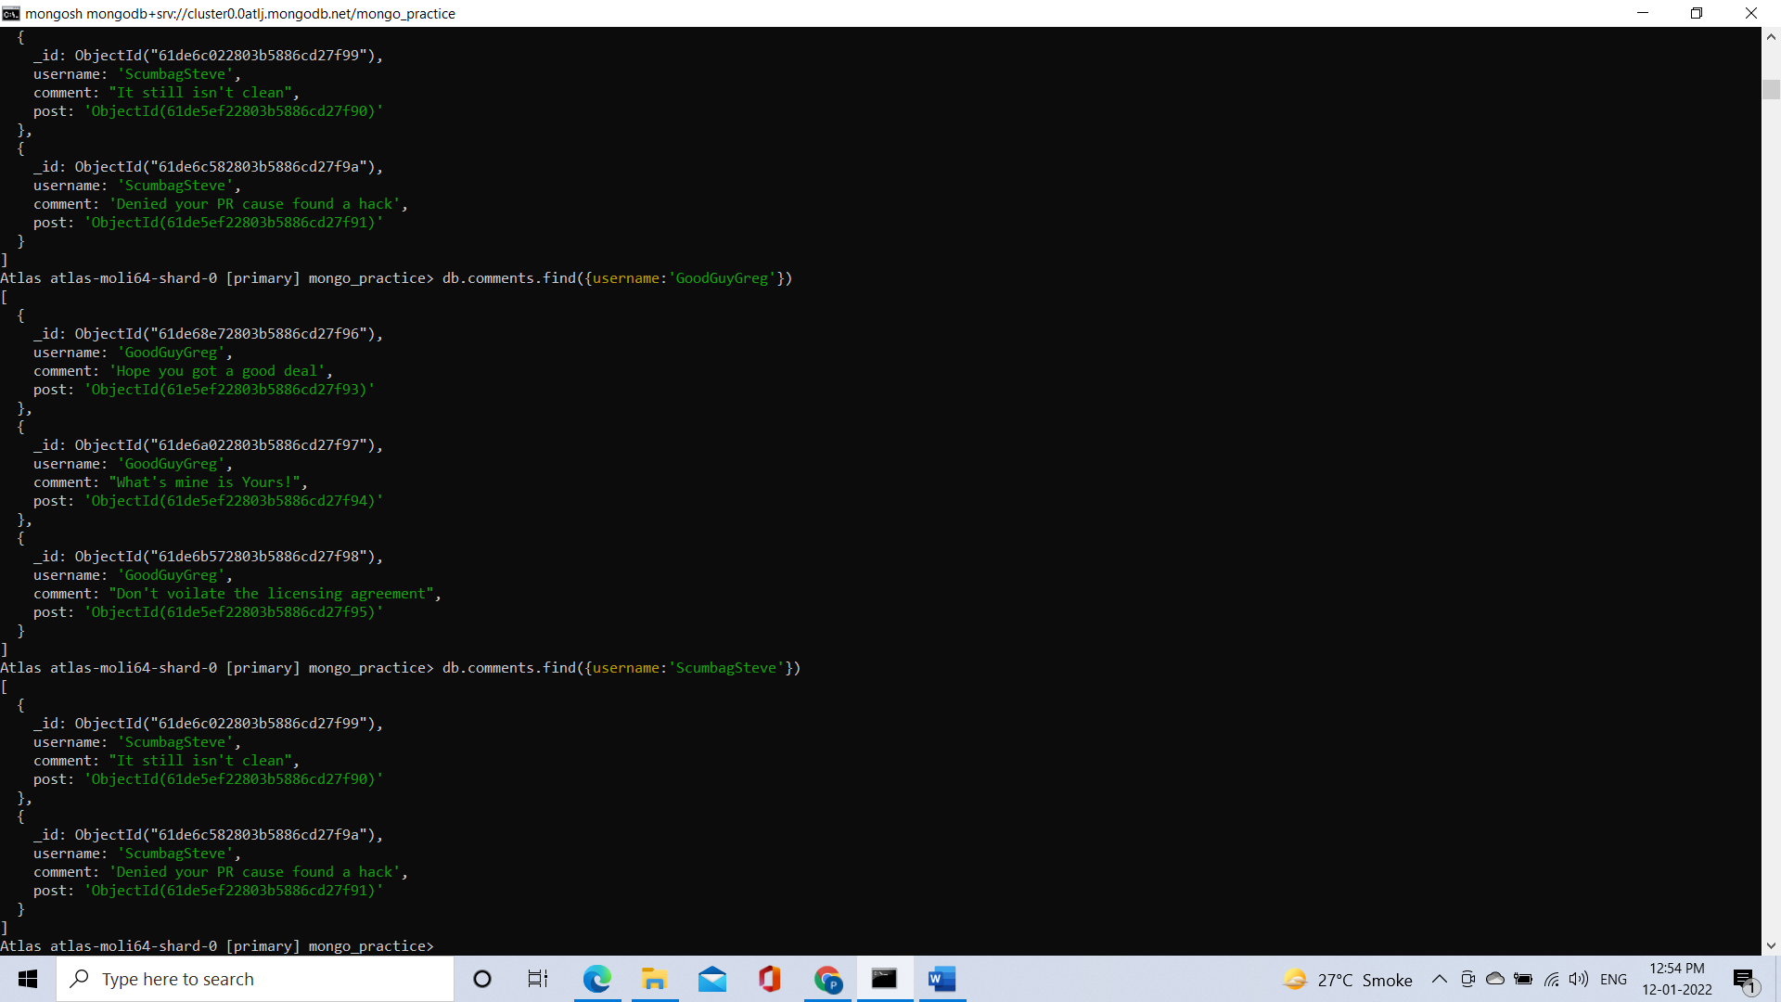

**8. find all comments belonging to the post "Reports a bug in your code"**

